Name ____________________________________ Date ______________ Period ______
Solve the following problems. Color the corresponding section of the picture that matches your answer.

GREEN The product of a number and 3 decreased by 7 is 8.

YELLOW The quotient of a number and 2 increased by 5 is 6.5.

BROWN 5 plus six times a number is 29.

ORANGE Eleven less than a number times -9 is -2.
BLUE 1 plus a number divided by four is $\frac{1}{2}$.

RED A number times 3 plus 50 is 17.

PURPLE Seven less than half a number is -10.

ORANGE STRIPES A number times $\frac{1}{3}$ and increased by 16 is equal to 12.

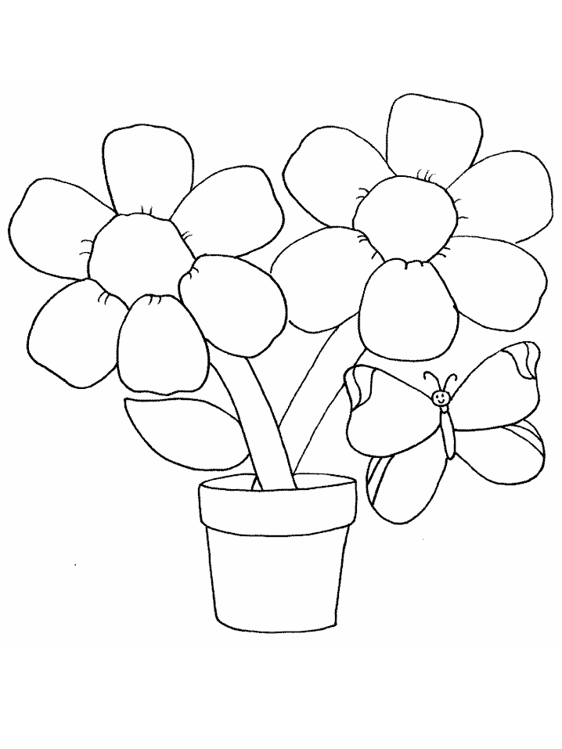RED POLKA DOTS Half a number plus 5 is one
-11
-11
-11
-1
-1
-1
-2
-2
-2
-6
-6
-6
-8
-8
-12
-12
3
3
5
5
5
4
4

Green = 5 Orange = -1 Blue = -2 Purple = -6

Yellow = 3 Brown = 4 Red = -11 Orange Stripes = -12

Red Polka Dots = -8

