Name: ______________________ Period: _____ Date: ______________
HW: Glencoe 6-7 Skills Practice adapted
#1-10: Write the rule, in coordinate form, that is necessary to accomplish each translation.
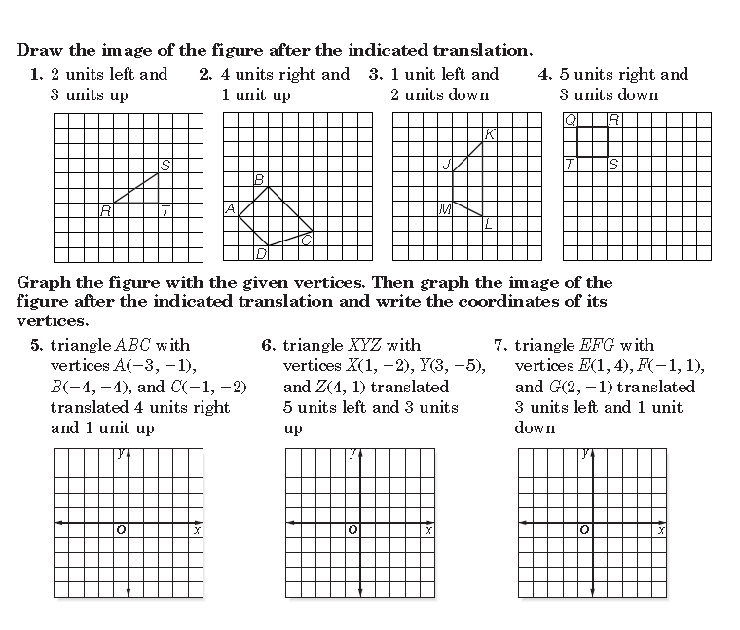
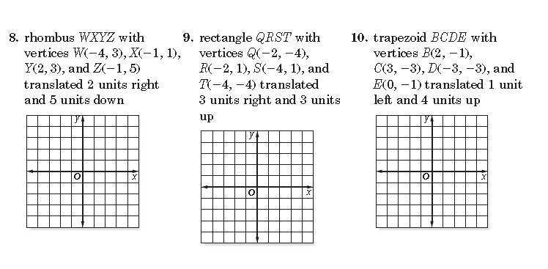
Name: ______________________ Period: _____ Date: ______________
HW: Glencoe 6-7 Practice adapted
#1-6: Write the rule, in coordinate form, that is necessary to accomplish each translation.
