Name:_________________________________ Period:_____________ Date:_________
Test Review - Multiple Representations and Compare and Order rational numbers
- You have to have electrical work done on your home. You call an electrician who tells you that she charges $40 per hour and a service call fee of $20. What is the equation if y, represents the total charge for the visit, and x represents the number of hours? Is this a proportional or non-proportional relationship? Explain.

- Given the sequence 7, 11, 15, 19, 23,…, make a table and write the equation. Find the nth term for when n = 11.

- Use information in the graph below to create a table, and then use the table to find your equation.
Also answer the following questions about the graph.
- Does this graph represent a proportional or
non-proportional relationship? Justify your
answer.

- If you had 6 hours of work, how much did you make?

- If you made $130, how many hours did you work?

- A sequence of numbers was generated using the expression 7n – 6, where n represents a number’s position in the sequence. Generate the first 5 terms of the sequence.

- Heather has the following numbers two numbers $\frac{2}{3}$ and $\frac{4}{5}$. Heather wants to know which numbers fit in between these two numbers. Out of these four numbers which numbers fit in between Heather’s numbers: $\frac{3}{4}$, $\frac{7}{8}, \frac{7}{10},\frac{7}{12}$.

- The value of y is 6 times the value of x. What is the equation? Is this a proportional or non-proportional relationship? Explain.

- Given the following set of numbers 312%, 3 $\frac{1}{4}$, 3.14%, 3 $\frac{1}{8}$ , and 3.2 what is the order of the numbers from least to greatest?
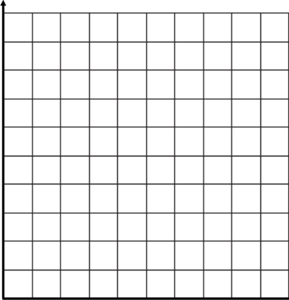
- The cost of renting a dry cleaning machine is $10 per day and a $5 rental insurance fee. Write an equation to represent y, the total amount to rent the cleaning machine for x number of days?
50

Equation: _________________
40
x | Process: | y
1
3
7
9
30

20
10
0 1 2 3 4 5 6 7 8 9 10

