Name _______________________________________ Date ___________ Period ________

Instructions: Number the faces and bases of each figure. Label the length of each side/radius on each base/face. Show calculations next to the shape on each net.
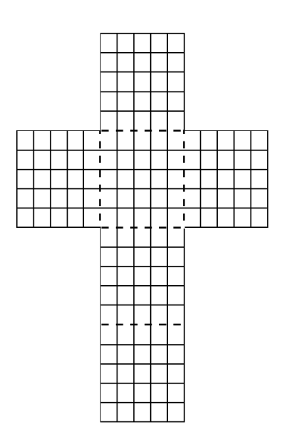

CUBE

Calculated Surface Area (Identify 2 faces as bases)
 | SHAPE | Area Formula | AREA
Face 1
Face 2
Face 3
Face 4
Face 5
Face 6
TOTAL

Total Surface Area ___________________

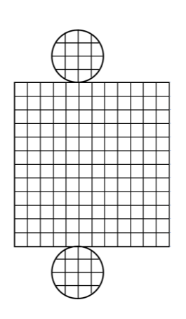
CYLINDER

Area of Bases
 | SHAPE | Area Formula | AREA
Base 1
Base 2
TOTAL

Lateral Surface Area
 | SHAPE | Area Formula | AREA
Lateral Face

Total Surface Area ___________________

RECTANGULAR PRISM

Area of Bases
 | SHAPE | Area Formula | AREA
Base 1
Base 2
TOTAL

Lateral Surface Area
 | SHAPE | Area Formula | AREA
Lat.Face 1
Lat.Face 2
Lat.Face 3
Lat.Face 4
TOTAL

Total Surface Area ___________________

TRIANGULAR PRISM

Area of Bases
 | SHAPE | Area Formula | AREA
Base 1
Base 2
TOTAL

Lateral Surface Area
 | SHAPE | Area Formula | AREA
Lat.Face 1
Lat.Face 2
Lat.Face 3
TOTAL

Total Surface Area ___________________

