STAAR Session #6 Equations and Proportional Relationships

Wednesday, March 19, 2013

A proportional relationship can be identified by looking at 3 things:

* The table has a constant rate of change AND a constant of proportionality (will reduce to the same fraction).
* The graph of the line goes through the origin.
* The equation fits the equation *y=kx* (no +/-).

**Proportional Relationship Non Proportional Relationship**

Monica’s health club charges $30 per month for a membership fee and $10 per fitness class. How many classes can Monica take in one month for $100.

A candy necklace costs $1.20. Jaden wants to buy candy necklaces for all of her friends. She only has $15 to spend. How many necklaces can Jaden buy?

* 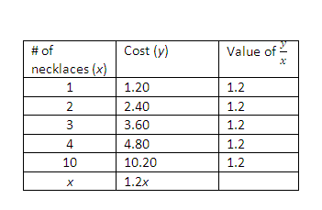

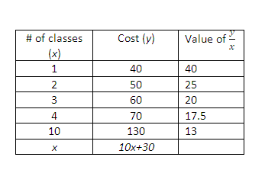

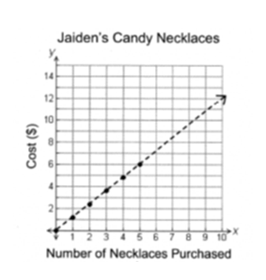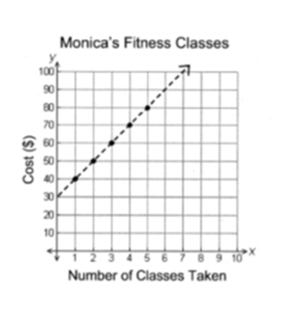

There is NOT a constant of proportionality.

There is a constant rate of change of $10.00 per class but the equation does not fit the form *y=kx.*

There is a constant of proportionality of 1.2 .

There is a constant rate of change of $1.20 and the equation fits the form *y=kx.*

Proportional Graphs go through the origin (0,0).

Non-Proportional graphs do not.

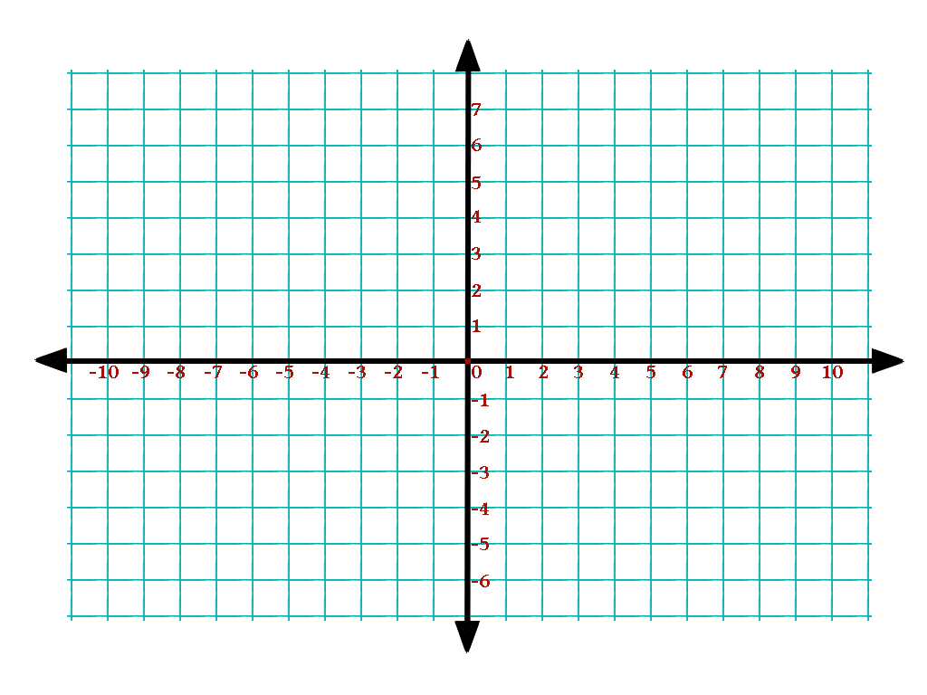Which of the following graphs shows a non-proportional relationship?

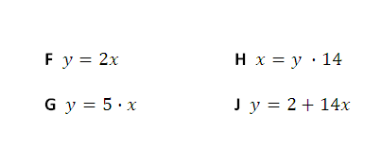Which of the following equations does **not** represent a proportional relationship?

**F $y=2x$** **H $x=y ∙14$**

**G $y=5∙x$**  **J $y=2+14x$**

Which table shows a proportional relationship?

|  |  |
| --- | --- |
| Number of Apples | Total Cost |
| 5 | $2.00 |
| 10 | $4.00 |
| 15 | $6.00 |
| 30 | $10.00 |

|  |  |
| --- | --- |
| Number of Apples | Total Cost |
| 5 | $2.50 |
| 10 | $5.00 |
| 15 | $7.50 |
| 30 | $15.00 |

|  |  |
| --- | --- |
| Number of Apples | Total Cost |
| 5 | $1.75 |
| 10 | $3.50 |
| 15 | $7.75 |
| 30 | $15.00 |

|  |  |
| --- | --- |
| Number of Apples | Total Cost |
| 5 | $1.25 |
| 10 | $2.50 |
| 15 | $5.00 |
| 30 | $15.50 |

**When moving between tables, graphs and equations remember: plug it in, plug it in!**

The table below shows a relationship between $x$ and $y$.

|  |  |
| --- | --- |
| $$x$$ | $$y$$ |
| 0 | 3 |
| 1 | 8 |
| 3 | 18 |
| 4 | 23 |
| 6 | 33 |

Plug in the x values from the table to solve for y.

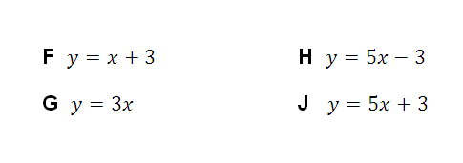Which equation best represents this relationship?

**F $y=x+3$** **H $y=5x-3$**

**G $y=3x$** **J $y=5x+3$**

Which of these equations represents the graph below?

Make a table with points from the graph and compare to the equations OR plug in values 0, 1, 2 … into each equation to see if they are on the line.

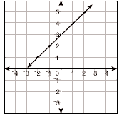**A** 

**B** 

**C**  

**D** 

The cost to lay sod is given by the equation $c=0.09A$ where $c$ is the total cost, and $A$ is the area of the yard. Which table contains values that fit the equation?

Plug in values from the tables into the equation.

|  |  |  |  |  |
| --- | --- | --- | --- | --- |
| *A* | 10 | 20 | 30 | 40 |
| *c* | 0.09 | 0.18 | 0.27 | 0.36 |

|  |  |  |  |  |
| --- | --- | --- | --- | --- |
| *A* | 10 | 20 | 30 | 40 |
| *c* | 0.90 | 1.80 | 2.70 | 3.60 |

|  |  |  |  |  |
| --- | --- | --- | --- | --- |
| *A* | 10 | 20 | 30 | 40 |
| *c* | 9.00 | 18.00 | 27.00 | 36.00 |

|  |  |  |  |  |
| --- | --- | --- | --- | --- |
| *A* | 10 | 20 | 30 | 40 |
| *c* | 90 | 180 | 270 | 360 |

Sophia joined Netflix and she can find her monthly charges using the expression 3n + 5. Which list will show Sophia’s monthly charges depending on the number of movies rented?

Remember: Put the term numbers over the list.

Plug the term numbers into the given equation.

1, 2, 3, 4, 5

1. 5, 10, 15, 20, 25,… C. 3, 9, 12, 15, 18,…

B. 3, 8, 13, 18, 23,… D. 8, 11, 14, 17, 20,…

