AM STAAR Session #5 Scale Factor and Similar Figures

Thursday, March 28, 2013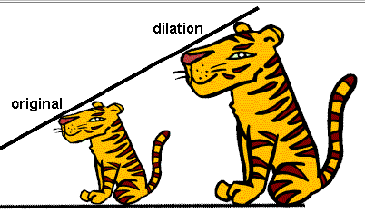

A **dilation** is a transformation in which a figure and its image are similar.

The number that is multiplied by the dimensions of the original figure to reduce or enlarge it is called the **scale factor.**

* If the scale factor is **greater than 1** the image **gets larger.**
* If the scale factor is **less than 1, but greater than 0,** the picture **gets smaller.**

A square poster was reduced in size as shown below. What is the scale factor used for the reduction?

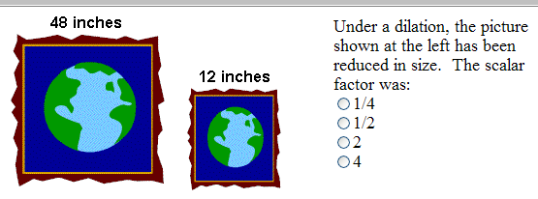

We find the scale factor by using the ratio $\frac{new }{old}$

*We know the scale factor is less than 1 because the image is smaller than the original.*

$\frac{new}{old}=\frac{12}{48}=\frac{1}{4}$ Scale Factor = $\frac{1}{4}$ = 0.25= 25%

When we are missing a side, we can **multiply** thecorresponding side length (same place; different shape) by the scale factor to find the missing dimension.

Triangle 1 is similar to Triangle 2. What is the height of triangle 2?

15 ft

12 ft

7.5 ft

*x*

Triangle 1 Triangle 2

$\frac{new}{old}=\frac{7.5}{15}=\frac{1}{2}$**Scale Factor** = $\frac{1}{2}$ = 0.5 0.5 X 12 = 6.0 x = 6 feet

**STAAR Practice**

1. Jamie has a movie poster that measures 30 inches by 30 inches. If he wants to reduce it by a scale factor of $\frac{2}{5}$, what will be the length of each side of the new picture? Draw a picture!!!!!!

1. 60 in. C. 24 in.

B. 75 in. D. 12 in.

2. Equilateral triangle TRY is similar to triangle NOW.

N

O

W

2.5

T

R

Y

1.5

What scale factor was used to dilate equilateral triangle TRY to NOW?

1. 5
2. 3

3. Laura drew a right isosceles triangle on a sheet of paper. The triangle is projected to create an image dilated by a scale factor of 2.5. If the length of a leg of the new triangle is 6 inches, what is the length in inches of a leg of the original triangle on the paper?

Record your answer and **fill in the bubbles**. **Be sure to use the correct place value.** 

You can also use a **proportion** to solve for a missing side. Remember: **Label your proportions**!!

$$\frac{big}{small} \frac{9}{x}=\frac{7}{3.5}$$

The parallelograms below are similar.  
What is the length of *JK*?

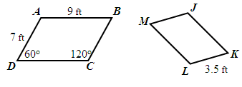

**Look for a shortcut!!! $7÷2=3.5 so 9÷2=4.5$**

$$JK=4.5 feet$$

If you can’t find a shortcut, solve using a ratio table.

1. The trapezoids above are similar. What is the length of *RS?*

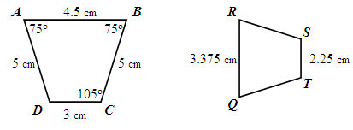

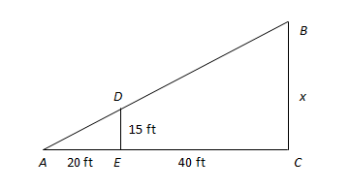2. Triangle *ABC* is similar to Triangle *ADE*. What is the distance from Point *B* to Point *C*?

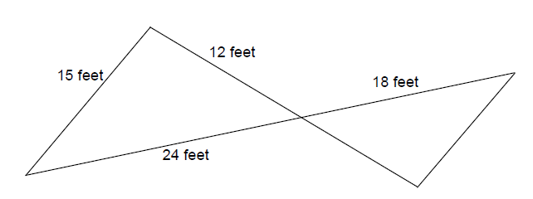3. John Turelli Park is building a large sandbox in the shape of two similar triangles as shown below. How many feet of edging will it take to go around the innovative sandbox?

CHALLENGE!!!

Below is a map of the junctions of several streets in Pine Hills. First, Second, and Third

Streets all run parallel. They all intersect Eddy Street and Cedar Street as shown in the map below.

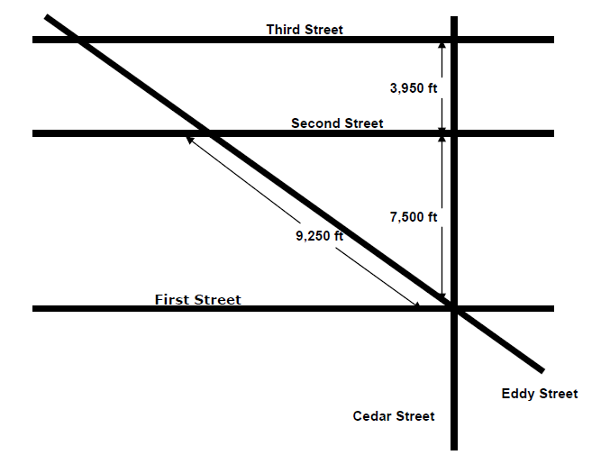

Use a proportion to solve for the length of Eddy Street between Second and Third Streets. Round your answer to the nearest foot.