 Scientific Notation

& Approximating Square Roots

### express numbers in scientific notation, including negative exponents, in appropriate problem situations

Numbers written in scientific notation have two factors. The first factor is a number between 1 and 10. The second factor is a power of 10.

***change from standard form to scientific notation***

**Step 1**: Move the decimal point so there is one non-zero digit to the left of the decimal point (*a number* ***greater*** *than* ***1*** *and* ***less*** *than* ***10****).*

Example: Given:  4,750,000 use: 4.75

**Step 2:** Count the number of decimal places the decimal has "moved" from the original number.  This will be the exponent of the 10.

Example: 4,750,000 to 4.75 *(moved* ***6*** *decimal places)*

answer:  **4.75 X 106**

***The original number was greater than 1 so the exponent is positive.***

***If the original number was ***less than 1***, the exponent is ***negative.***

Example: Given:  0.000789 use: 7.89

0.000789 to 7.89 (moved 4 decimal places)

answer:  **7.89 x 10-4**

***The original number was less than 1 so the exponent is negative.***

|  |  |
| --- | --- |
| Planet | Average distance from the sun (km) |
| Earth | 150 million |
| Jupiter | 779 million |
| Mars | 228 million |
| Mercury | 57 million |
| Neptune | 4500 million |
| Saturn | 1430 million |
| Uranus | 2880 million |
| Venus | 108 million |

**STAAR Practice**

In science class, Misty was learning about the solar system. She wanted to write a report about the distance of each planet from the Sun. She found a table that displays this information.

Write the distance of the planet furthest from the Sun in scientific notation.

**___________________________________________**

***change from scientific notation to standard form***

Move the decimal point to the ***right*** for a ***positive*** exponent of **10**.

|  |  |
| --- | --- |
| Example: Given:  5.024 x 103 | |
| **answer:**  **5,024** (**3** places to the **right**) | Positive exponent - move the decimal to the **right**. |

**\*\*\*Hint: A positive exponent tells you the standard form will be greater than 1.**

Move decimal point to ***left*** for ***negative*** exponent of **10**.

|  |  |
| --- | --- |
| Example: Given:  1.015 x 10-8 | |
| **answer:**  **0.00000001015** (**8** places to the **left**) | Negative exponent - move the decimal to the **left**. |

**\*\*\*Hint: A negative exponent tells you the standard form will be less than 1.**

**STAAR Practice**

The unit price of 1 ounce of Biff creamy peanut butter is $0.094. How would this value be written in scientific notation?

A. $0.94 × {10}^{-1}$

B. $9.4 × {10}^{2}$

C. $9.4 × {10}^{1}$

D. $9.4 ×{10}^{-2}$

The equatorial diameter or the Earth is 7,926.6 miles. How would this distance be represented in scientific notation?

A. $7.9 × {10}^{3}$

B. $7.9266 × {10}^{3}$

C. $7.999999266 × {10}^{-3}$

D. $7.9266 × {10}^{-3}$

**Approximating Square Roots**

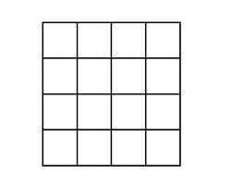

Sixteen tiles make a square with four tiles on a side.

* The square of 4 is 16.

4 units



* The square root of 16 is 4 because $4^{2}=16.$

 $\sqrt{16}=4$

4 units

Numbers that can form squares are perfect squares.

Their square roots are whole numbers.

$1^{2}=1$ $2^{2}=4$ $3^{2}=9$

$\sqrt{1}=1$ $\sqrt{4}=2$ $\sqrt{9}=3$

Whole numbers that are not perfect squares still have square roots.  However, their square roots are not whole numbers; they are decimals or fractional parts of whole numbers. The non-terminating, non repeating decimals are called **irrational numbers**.



You can estimate square roots for numbers that are not perfect squares by using the calculator.

Estimate  Estimate $\sqrt{97}$

Graph these numbers on the number line.

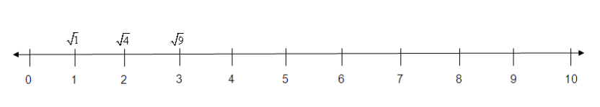

**STAAR Practice**



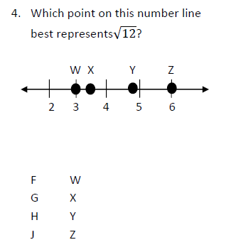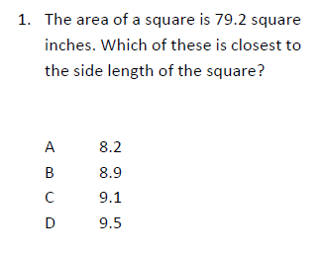

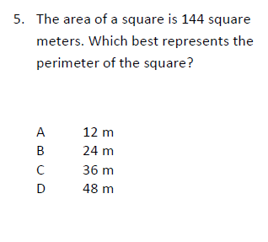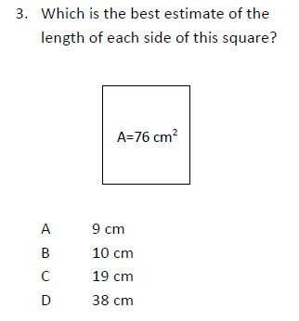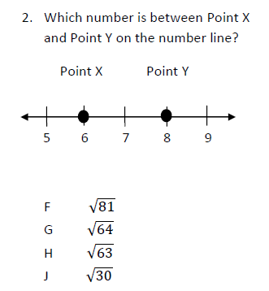

6.

[Type a quote from the document or the summary of an interesting point. You can position the text box anywhere in the document. Use the Text Box Tools tab to change the formatting of the pull quote text box.]