 Pythagorean Theorem & Translations

Use Pythagorean Theorem to solve real-life problems.

**Pythagorean Theorem-** This theorem is used to find the missing side of any right triangle (no other type of triangle). The longest side of a triangle is called the **hypotenuse**. The hypotenuse is opposite the right angle.

The other 2 sides of the triangle are the **legs**. The legs can be found by locating the  box. The box holds on to the two legs of a right triangle.

**Pythagorean Theorem** says:

**a2 + b2 = c2**

b (leg) C (hypotenuse)

a (leg)





Pythagorean Practice

1. Find the lengths of the 3 sides of the triangle.

a=_____

**1. Plot the given points.**

**2. Label sides a, b and c. Remember, c is the longest side across from the right angle.**

**3. Solve for the missing side using Pythagorean Theorem.**

b=_____

c=_____

2. Two birds leave the same birdhouse at the same time. The first bird flies to a tree 25 miles south, while the other bird flies to a tree 15 miles west. **About** how far apart are the two birds after they land? Hint: Draw a picture.

3. A right triangle is shown below.

The triangle is dilated by a scale factor of 1.5 to create a new triangle.

12 in.

9 in.

What is the perimeter of the new triangle?

1. 54 in. C. 37.5 in.

B. 22.5 in. D. 162 in.

4. The ladder of the slide shown below is perpendicular to the ground.

17 ft

8 ft

Children wanted to know how far they would have to walk back to the ladder to use the slide again. Which child found the correct distance, and gave to correct validation of their distance?

1. Tony said 9 ft, because he subtracted the height of the ladder from the length of the slide.
2. Araceli said 15 ft, because she subtracted the square of the height of the ladder from the square of the length of the slide, and took the square root of that difference.
3. John said 19 ft, because he added the square of the height of the ladder to the square of the length of the length of the slide, and took the square root of that sum.
4. Misty said 25 ft, because she added the height of the ladder to the length of the slide.

Transformations

Graph dilations, reflections and translations on a coordinate plane.

A transformation is a change in a geometric shape.

There are 4 kinds of transformations.

A.) A **reflection** is the **mirror image** of a shape.

B.) A **translation** is the **slide** of a shape.

C.) A **rotation** is the **turn** of a shape.

D.) A dilation enlarges or reduces the size of a shape.





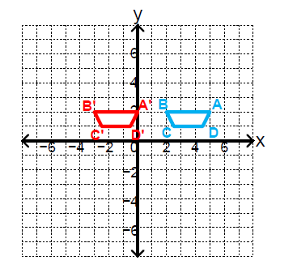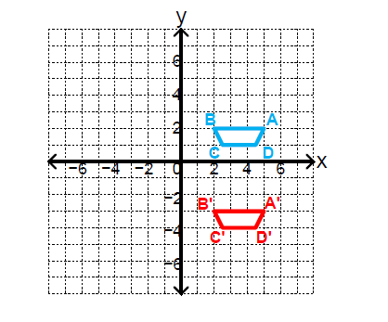

Translation 5 units right

Translation 5 units down

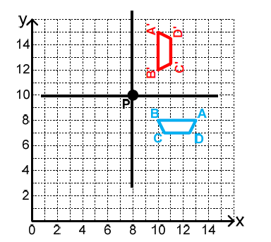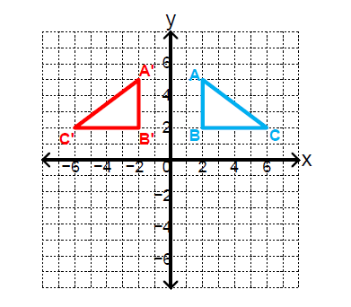

Reflection across the y-axis

Rotation

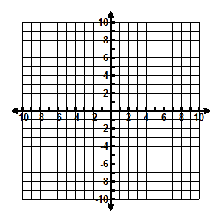1.) Beatrice translated trapezoid *RSTU* to trapezoid *R′S′T′U′.* Vertex *S* was at (4 , 1).

If vertex *S′* is at (-3 , 4), which best describes this

translation?

A. Move 7 units left and 3 units up

B. Move 1 unit left and 3 units up

C. Move 3 units down and 7 units right

D. Move 8 units left and 4 units up

2.) The figure below was transformed from quadrant I to quadrant III.

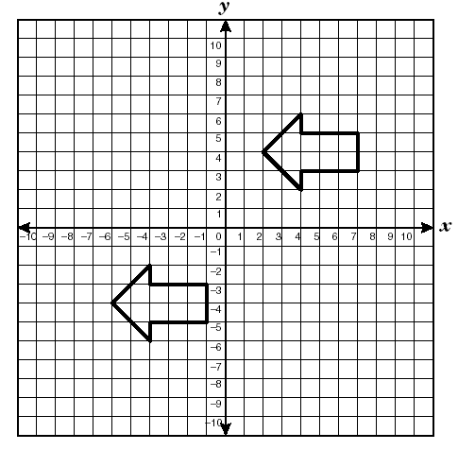

This transformation best represents a –

A. translation

B. tessellation

C. rotation

D. reflection

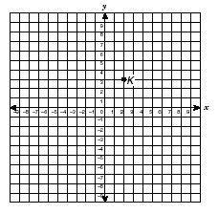3.) Circle K is translated 4 units to the left and 3 units down. What are the new coordinates of the center of Circle K?

F. (-2 , 0)

G. (6 , 0)

H. (-1 , -1)

J. (5 , -1)

4.) Abby wants to translate polygon ABCD so that **Vertex D** is moved to coordinates

(4, -2). Identify the steps that can be used for the translation.

A. Move Vertex D 5 units to the right and 4 units up



B. Move Vertex D 5 units to the right and 2 units up

# C. Move Vertex D 4 units to the right and 1 unit up

D. Move Vertex D 2 units to the right and 5 units up