 Equations and Proportional Relationships

A proportional relationship can be identified by looking at 3 things:

* The table has a constant rate of change AND a constant of proportionality (will reduce to the same fraction).
* The graph of the line goes through the origin.
* The equation fits the equation *y=kx* (no addition or subtraction allowed).

**Proportional Relationship Non Proportional Relationship**

Monica’s health club charges $30 per month for a membership fee and $10 per fitness class. How many classes can Monica take in one month for $100.

A candy necklace costs $1.20. Jaden wants to buy candy necklaces for all of her friends. She only has $15 to spend. How many necklaces can Jaden buy?

* 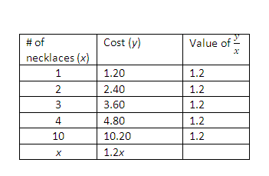

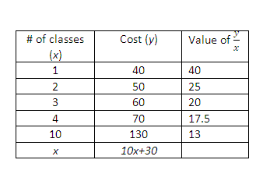

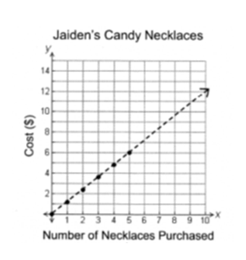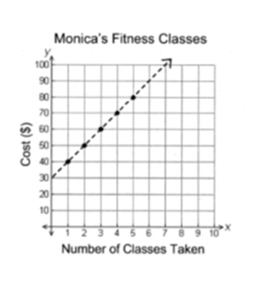

There is NOT a constant of proportionality.

There is a constant rate of change of $10.00 per class but the equation does not fit the form *y=kx.*

There is a constant of proportionality of 1.2 .

There is a constant rate of change of $1.20 and the equation fits the form *y=kx.*

Proportional Graphs go through the origin (0,0).

Non-Proportional graphs do not.

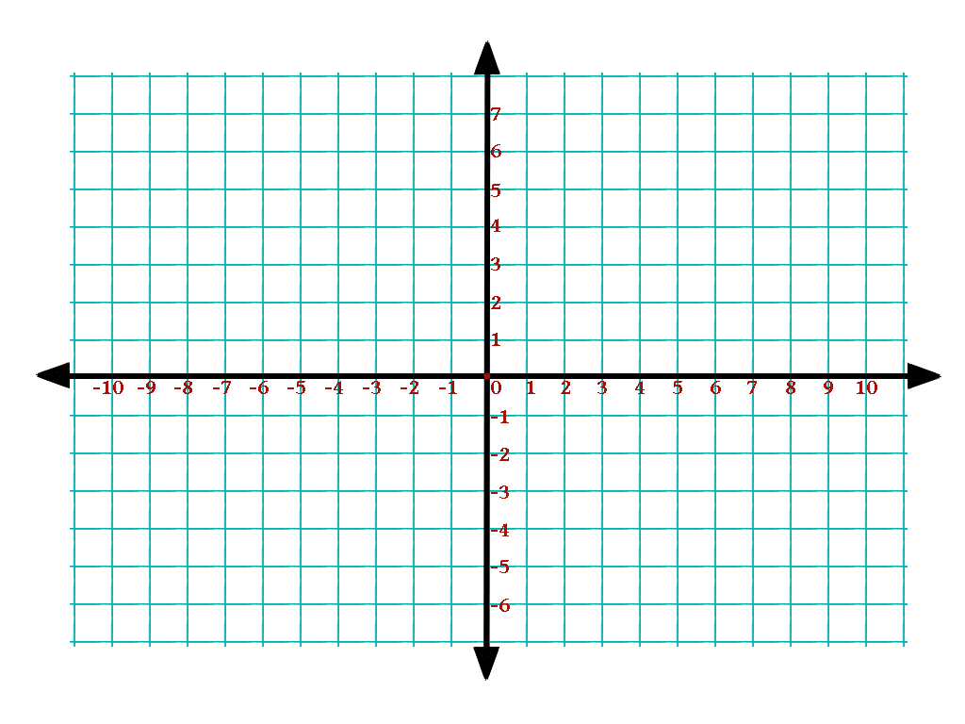Which of the following graphs shows a non-proportional relationship?

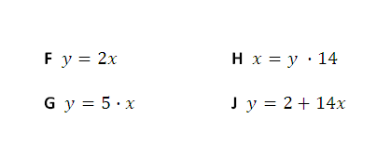Which of the following equations does **not** represent a proportional relationship?

**F $y=2x$** **H $x=y ∙14$**

**G $y=5∙x$**  **J $y=2+14x$**

Which table shows a proportional relationship?

|  |  |
| --- | --- |
| Number of Apples | Total Cost |
| 5 | $2.00 |
| 10 | $4.00 |
| 15 | $6.00 |
| 30 | $10.00 |

|  |  |
| --- | --- |
| Number of Apples | Total Cost |
| 5 | $2.50 |
| 10 | $5.00 |
| 15 | $7.50 |
| 30 | $15.00 |

|  |  |
| --- | --- |
| Number of Apples | Total Cost |
| 5 | $1.75 |
| 10 | $3.50 |
| 15 | $7.75 |
| 30 | $15.00 |

|  |  |
| --- | --- |
| Number of Apples | Total Cost |
| 5 | $1.25 |
| 10 | $2.50 |
| 15 | $5.00 |
| 30 | $15.50 |

**When moving between tables, graphs and equations remember: plug it in, plug it in!**

The table below shows a relationship between $x$ and $y$.

|  |  |
| --- | --- |
| $$x$$ | $$y$$ |
| 0 | 3 |
| 1 | 8 |
| 3 | 18 |
| 4 | 23 |
| 6 | 33 |

Type each equation in your graphing calculator and look at the table by pressing ctrl T

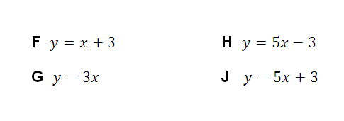Which equation best represents this relationship?

**F $y=x+3$** **H $y=5x-3$**

**G $y=3x$** **J $y=5x+3$**

Which of these equations represents the graph below?

Type each equation in your graphing calculator and look at the table by pressing ctrl T. Then check each point in the table to see if they are on the line.

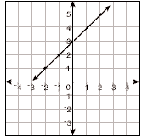**A** 

**B** 

**C**  

**D** 

The cost to lay sod is given by the equation $c=0.09A$ where $c$ is the total cost, and $A$ is the area of the yard. Which table contains values that fit the equation?

Type the equation in your graphing calculator and look at the table by pressing ctrl T

|  |  |  |  |  |
| --- | --- | --- | --- | --- |
| *A* | 10 | 20 | 30 | 40 |
| *c* | 0.09 | 0.18 | 0.27 | 0.36 |

|  |  |  |  |  |
| --- | --- | --- | --- | --- |
| *A* | 10 | 20 | 30 | 40 |
| *c* | 0.90 | 1.80 | 2.70 | 3.60 |

|  |  |  |  |  |
| --- | --- | --- | --- | --- |
| *A* | 10 | 20 | 30 | 40 |
| *c* | 9.00 | 18.00 | 27.00 | 36.00 |

|  |  |  |  |  |
| --- | --- | --- | --- | --- |
| *A* | 10 | 20 | 30 | 40 |
| *c* | 90 | 180 | 270 | 360 |

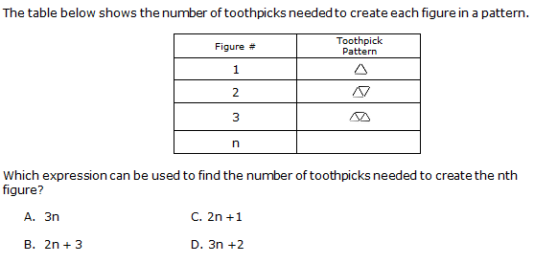

Type each expression in your graphing calculator and look at the table by pressing ctrl T. Remember to use the variable x instead of n when typing the equation.