STAAR Session #1 Comparing and Ordering Rational Numbers
Wednesday, March 19, 2013
Math Objective 8.1 A Compare and order rational numbers in various forms including integers, percents, and positive and negative fractions and decimals.

Before comparing and ordering, change all numbers in to the same form (decimals, percents, fractions…).

Integers - Integers are positive or negative whole numbers.
Remember : Descending means order from greatest to least. Ascending means order from least to greatest.

Use a number line to help you order the following numbers. 2 yd, -14 yd, - 18 yd, 34 yd, -15 yd, 5 yd, -3 yd.

Fractions

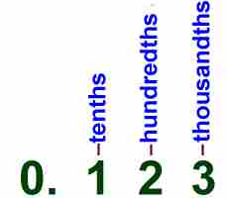
- To change a fraction to a decimal, you can write the fraction as a 10th, 100th or 1000th and write it using the correct place value.

Ex. $\frac{3}{8}=\frac{3×125}{8×125}=\frac{375}{1000} 0.375$ $\frac{24}{30}=\frac{}{}=$

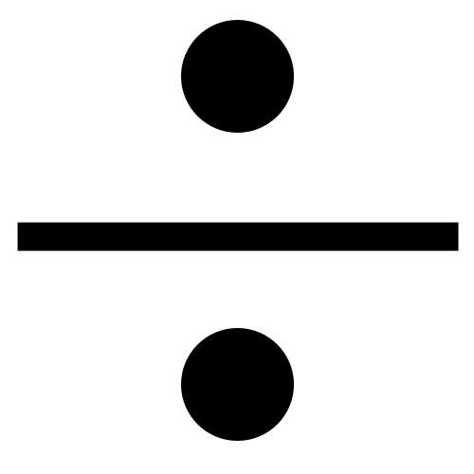

- If you cannot write it using a 10th, 100th or 1000th, divide the fraction using ‘top in, bottom out’.

Ex. $\frac{5}{7}=$ $\frac{2}{37}=$

- To change a fraction into a percent, write it as a decimal. Take the decimal and move it 2 places to the right and add your percent sign.
Ex. $\frac{2}{5}=0.4=40\%$ $\frac{3}{8}=$

- To compare fractions, write the fractions with common denominators and order them using their numerators. Remember, when making common denominators, what you do to the top, you do to the bottom.
Ex. $\frac{3}{5} \boxed{} \frac{5}{7} \frac{21}{35} <\frac{25}{35}$ $\frac{3}{8} \boxed{} \frac{1}{3}$

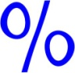
Percents - Percent means ‘per hundred’.

- To change a percent into a fraction, write the number over ‘100’ and reduce.

$$68 \% = \frac{68 }{100} \frac{÷4}{÷4}=\frac{17}{25}$$

- To change a percent into a decimal, write it as a fraction, reduce and divide top in, bottom out or move the decimal two places to the left.

Ex. $38.5\%=\frac{38.5}{100}=0.385$ Ex. $102.5\%=$

- To compare and order percents, write them as decimals and line them up vertically to compare.
Line up the decimals!!

Ex. $38.5\%, 0.385\%, 3.85\%, 3.6\%, 3.62\%$

Decimals
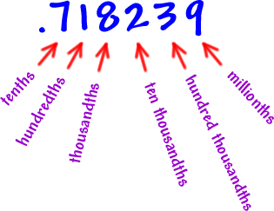
- To change a decimal into a fraction, use place value!
Ex. $0.32=\frac{32}{100}=\frac{8}{25}$ $0.26=$

- To change a decimal to a percent, move the decimal place two places to the right.
Ex.$0.525=52.5\%$ $1.26=$

- To compare and order decimals, write them vertically and line up the decimal places.
Ex.$0.27, 0.3, 1.3, 1.03, 3.0$

STAAR Practice

1. Winston plans to apply for a credit card. The monthly interest rates offered by 4 credit card companies are shown in the table below.
Credit Card Company | Interest rate
American Express | $$7\frac{1}{2}\%$$
Discover | $$7.8\%$$
MasterCard | $$7.375\%$$
Visa | $$7\frac{2}{3}\%$$
Which list shows the interest rates in order from least to greatest?
- American Express, Discover, MasterCard, Visa
- Visa, MasterCard, Discover, American Express
- MasterCard, American Express, Visa, Discover
- Discover, Visa, American Express, MasterCard

2. The table below shows the depth of four divers. Use the table to answer the questions that follow.

Diver | Depth of Dive  (feet from sea level)
Marion | -35
Jacob | -18
Charlie | -25
Celeste | -42

a. Which diver had the deepest dive?
________________________

b. Which diver is closest to the surface of the water?
________________________

c. List the four divers in order from deepest dive to most shallow dive.

____________, ____________, ____________, and __________

3. Which integer makes –19 < ___ < -13 true?

a. –20 b. –15 c. –10 d. 14

4. Look at the numbers below.

Which of the following statements best describes the numbers?

a. all the integers between 5 and – 5
b. all the integers less than 4
c. all the integers greater than – 3
- all the numbers between 5 and – 5

5. In the last ten games Percy made $\frac{7}{12}$ of his free throws. For the same period, Tarek made $\frac{4}{7}$ of his free throws. Which player has the better free throw record?

6. Beaker A has $4\frac{3}{10} fl oz$ of water. Beaker B has $4\frac{1}{3} fl oz$ of water. Which beaker has the smaller amount of water?

7. Which of the following comparisons is NOT true?

a. $\frac{19}{24}<\frac{11}{12}$ b.$\frac{4}{15}<\frac{1}{4}$

c.$\frac{7}{8}>\frac{5}{6}$ d. $\frac{7}{10}>\frac{2}{3}$

