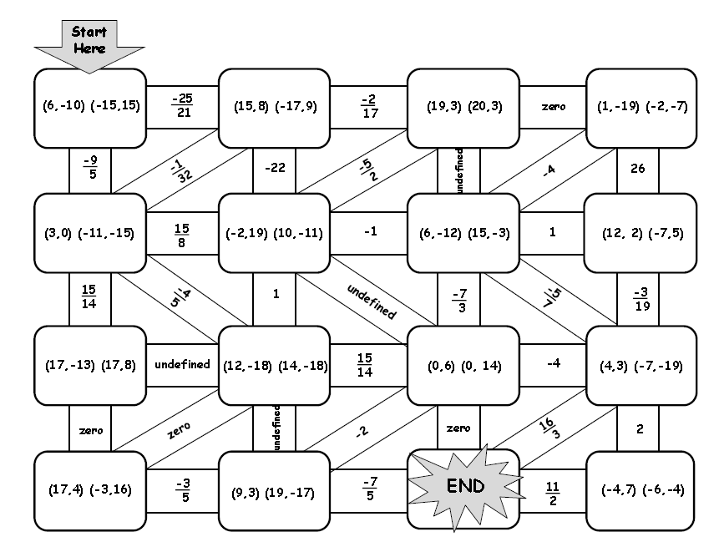

**SLOPE MAZE**

Start at the arrow and determine the slope of the line that is contained in each set of ordered pairs until you have reached the END space. Connect your path through the maze and also connect the problem to its answer.

Name _________________________________________