Name ________________









**Similar Figures**

1. Triangle 1 is similar to triangle 2. The statement below describes the 2 sets of criteria that are necessary for these two triangles to be similar.

**2**

30 inches

**1**

10 inches

12 inches

36 inches

**Use the word bank below to fill in the blanks; one of the words will be used twice.**

**corresponding proportional similar congruent**

In order for 2 figures to be ____________________, the ____________________ sides must

be ____________________, and the ____________________ angles must be

____________________.

1. Use the triangles below to answer the questions that follow. (triangle ABC  triangle DEF)

**F**

**E**

**D**

**C**

**B**

**A**

10 m

5 m

6 m

12 m

* 1. ACB corresponds to _______. b.  corresponds to _______.

1. _______ corresponds to EDF. d.  corresponds to _______.
2. BAC is congruent to _______.
3. △ LMN is similar to △ XYZ.

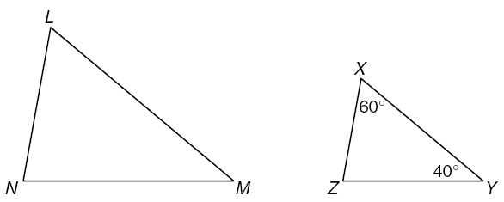

1.  corresponds to _______. b. _______corresponds to .
2. What is the measure of ? ________
3. What is the measure of ? ________
4. Which procedure can be used to find the number of degrees in ?

a. Subtract 100 from 360 c. Divide 100 by 2

b. Subtract 100 from 180 d. Divide 180 by 3

1. Regular pentagon MNPQR is similar to pentagon TUVWX.

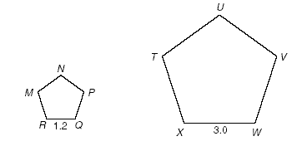

List at least 4 things that you know about these two pentagons:

A. B.

C. D.

1. Omar thinks that all rectangles are similar. Explain why Omar is either correct or incorrect.
2. Trapezoid *STUV* is similar trapezoid *NOPQ*.

18 cm

15 cm

12 cm

*U*

*V*

*T*

*S*

5 cm

4 cm

*Q*

*N*

*P*

*O*

Which of the following equations can be used to prove that trapezoid *STUV* and

trapezoid *NOPQ* are similar?

A.  =  C.  = 



B.  =  D.  = 

1. Which of the following is NOT true about similar figures?

A. Similar figures always have the same shape.

B. Similar figures always have the same size.

C. Similar figures always have corresponding angles that are equal.

D. Similar figures always have corresponding sides that are proportional.

8. Look at the 2 rectangles below.

*N*

*P*

*M*

*L*

4 units

3 units

*Y*

*Z*

*X*

*W*

2 units

1.5 units

Which method could be used to prove that the rectangles are similar?

A. Divide 3 by 2 and 4 by 1.5 to see whether the quotients are the same

B. Divide 1.5 by 4 and 2 by 3 to see whether the quotients are the same

C. Divide 4 by 1.5 and 2 by 3 to see whether the quotients are the same

D. Divide 3 by 1.5 and 4 by 2 to see whether the quotients are the same