Name:______________________________________________ Period:______ Date:_______________

Review for test Pt 2

1. 3 more than 5 times a number is 19.

2. 6.2 less than 1.5 times a number is 6.55

3. Art wanted to buy some painting supplies. He buys 6 brushes all at the same price, and a canvas for $5.50. If Art spent $20.50, how much was the cost of each brush.

4. A 15 foot ladder is leaning against a building. The base of the ladder is 9 feet from the building. Approximately how far up the building does the top of the ladder rest?

5. A triangle has a hypotenuse of 19 miles, and a leg of 15 miles. What would be the perimeter of this triangle?

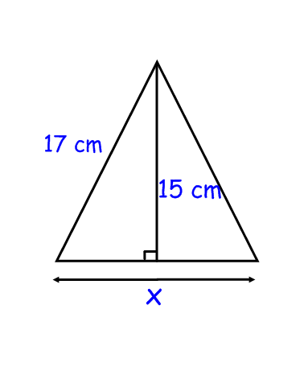6. Given the following picture to the right , what is the length of x the base of the triangle?

7. The diagram below shows how 3 square gardens were arranged to create a triangular courtyard in a park. If the sides of Garden A are 12 meters and the sides of Garden B are 16 meters long, what is the area of Garden C in square meters?

8. The floor of a moving truck is 5 feet of the ground. If the ramp used to unload furniture from the truck is 15 ft long, then how far is the truck from the end of the ramp, rounded to the nearest foot?



9. A bicycle race is being held in a local park. Each biker will begin his or her ride at point A, turn at points B and C, and then return to point A for the finish. How many total miles will a biker travel during the race?



10. Charlotte originally had $45 in her purse. She bought a magazine for $4.95 and a DVD for $17.49. She also paid $1.57 for sales tax. How much money does Charlotte now have left in her purse?

11. Gary and three of his friends went out for lunch. The lunch bill for all four of them, including tax and tip, was $39.80. If they split the bill evenly, how much did each person pay?

12. Jenny averaged 13.8 points per game during the last basketball season. If she played 15 basketball games, how many points did she score?

13. In the World Frog Jumping Championship, Willy defended his title by jumping distances of 6.5 feet, 5.85 feet, and 7.2feet. How many feet did Willy jump in total?

**Work Required: Chapter 2 section 10 pages 132-133 do all odd problems from 11-25, 31, 37** (check answers in the back of the book. Explain how you got the answer as your work.)

(Suggested, but optional) The following are example problems and then practice if you need to odd problems in the textbook for extra help. These are not required by sections you might want to look at.

Chapter 3 sections 5, 6, and 7 pages 162-178 any odd problems in the textbook.

Chapter 10 sections 2 and 3 pages 534-543 any odd problems in the textbook.

Chapter 2 section 2 pages 91-95 any odd problems in the textbook.

**19.55 8.5 400 16 3.2 24 207 45.7 14.1 2.5 20.99 12 9.95**