Proportions Name: _____________________

1. The rate of cars to people in New Zealand is 400 to 1000. Write this ratio as a fraction in simplest form.

[A]  [B]  [C]  [D] 

1. Marie has saved $54. On Wednesday, she spent $3 of her savings. What ratio

represents the portion of her total savings that she still has left?

[A] 1:9 [B] 17:18 [C] 15:16 [D] 8:9

1. Mrs. Walker drove to her sister’s house which was a distance of 679 miles. If she completed the trip in 13 hours of nonstop driving, did she comply with the 55 mi/h speed limit? Provide an explanation for your answer.
2. Refer to the figure below for a study conducted in the 1990s. Write a ratio to show the average number of VCRs per household in Spain as compared to the combined total of VCRs in Canadian and Japanese households.

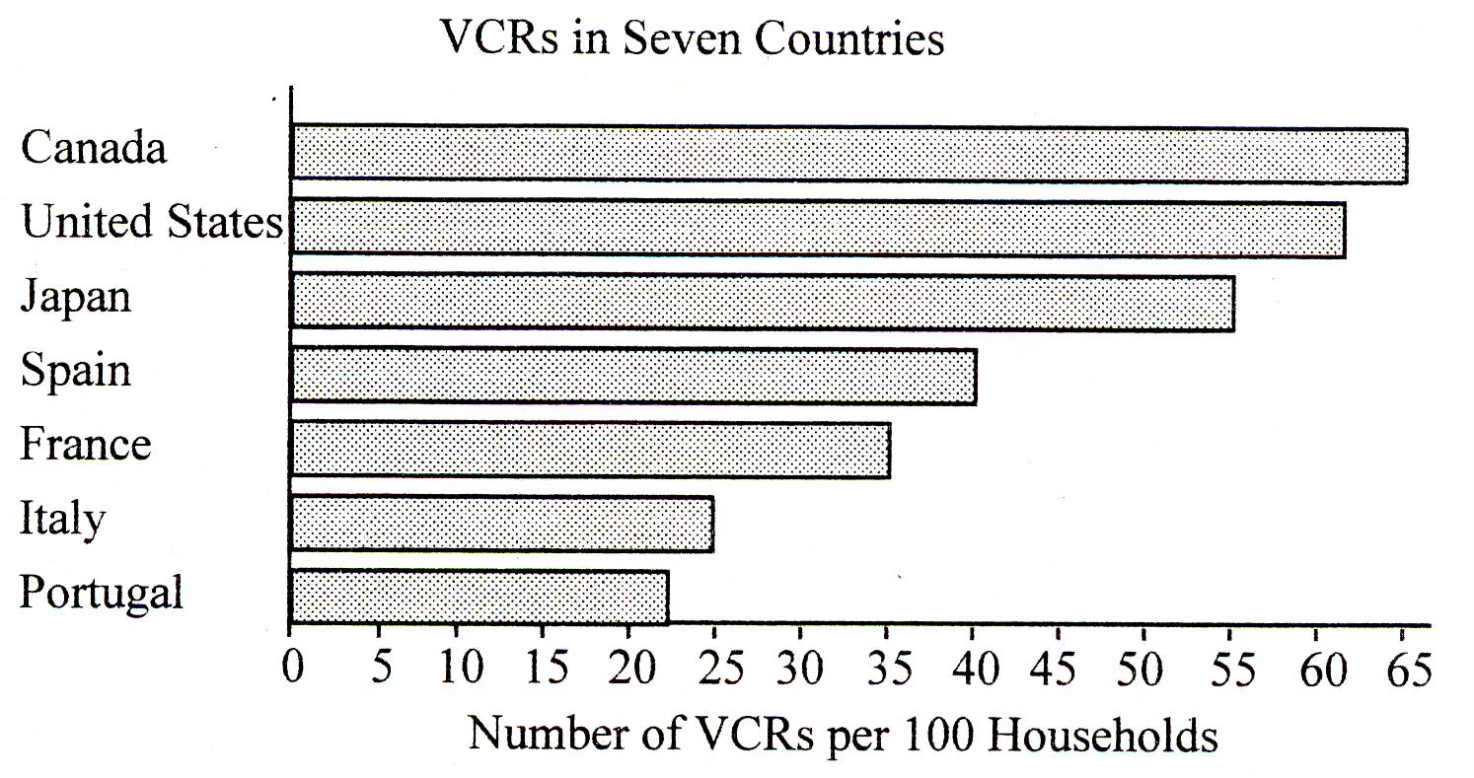

1. Patricia paid $515 for 5 nights in a hotel. What was the nightly rate for her room?
2. Jonah needs to purchase 24 juice packs for his class. While shopping, Jonah discovers the following prices for comparable juice packs. Which offers the best unit price?

[A] 8 packs for $2.09 [B] 12 packs for $2.79

[C] 4 packs for $0.99 [D] 1 pack for $0.33

1. A box of art supplies contains 32 markers. If there are 24 boxes in a case of supplies, how many markers does the case contain?
2. Find the missing term in the proportion: 

[A] 14 [B] 36 [C] 18 [D] 38

1. Which of the following proportions could be used to find the cost of 10 notebooks if 3 notebooks cost $1.98?

[A]  [B]  [C]  [D] 

1. A van travels 150 miles on 6 gallons of gas. How many gallons will it need to travel 600 miles?
2. A dozen apples costs $2.49. At this rate, how much would 5 apples cost?
3. The serving size for a chocolate cake contains 280 calories. If there are 12 servings in one cake, how many calories are there in an entire cake?
4. Are the two triangles (not drawn to scale) similar? If so, explain why they are.

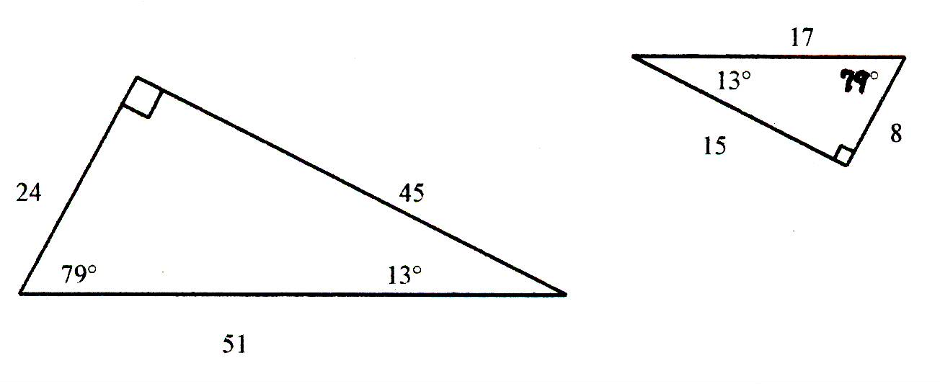

1. For the pair of similar polygons, find the missing side *n*.

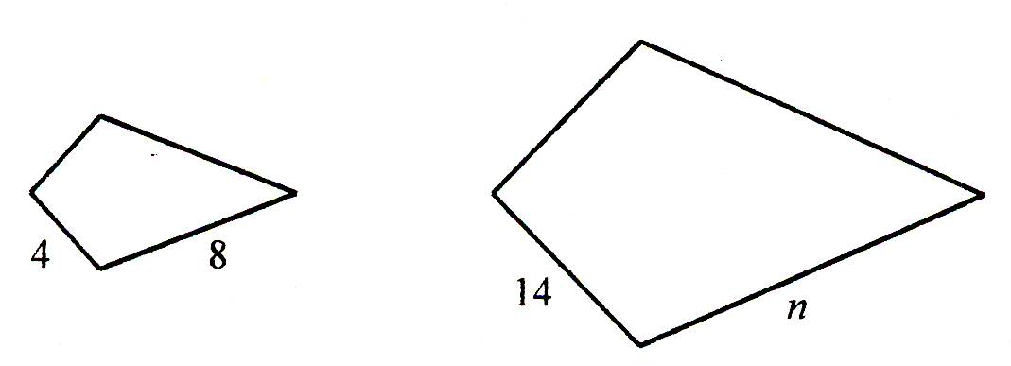

1. Use similar triangles to find *x*.

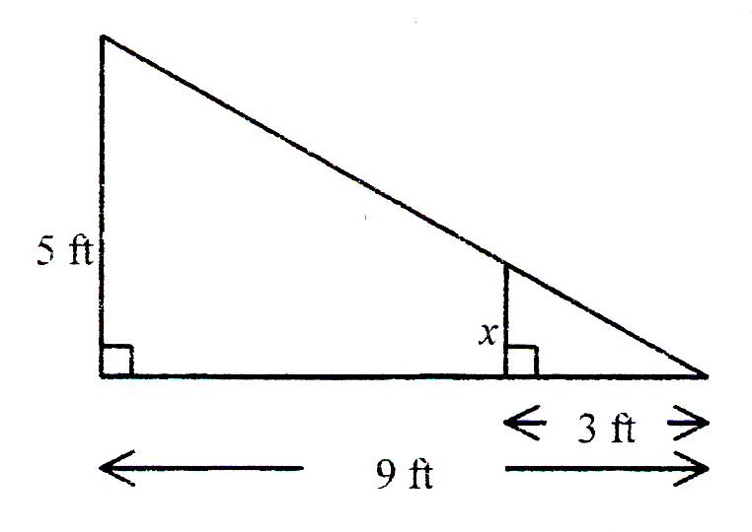

[A] 1.67 ft [B] 15 ft [C] 5.4 ft [D] 0.89 ft

1. The polygons shown below are similar. What is the length of side *m*?

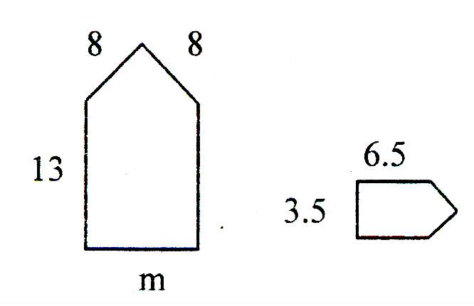

1. Use a proportion to find the length of side *X* in the figure below.

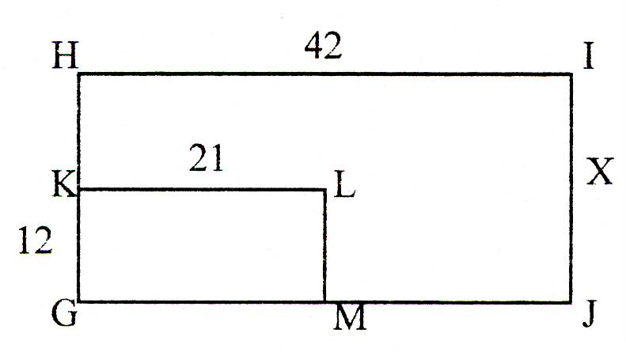

1. Suppose you want to enlarge the figure shown below so that is is 3.5 times larger. Explain to a friend how you could do it.

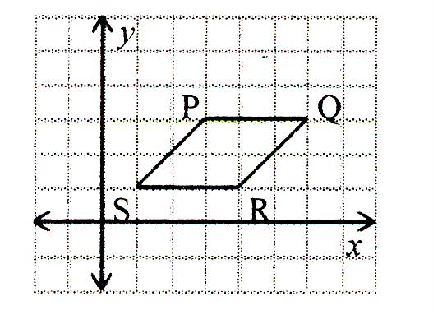

1. A map has a scale of 3cm: 6km. If two cities are 9cm apart on the map, what is the actual distance between the cities, to the nearest tenth of a kilometer?

[A] 180 km [B] 18 km [C] 4.5 km [D] 45 km

1. Find the perimeter of the actual object using the scale factor shown on the blueprint.

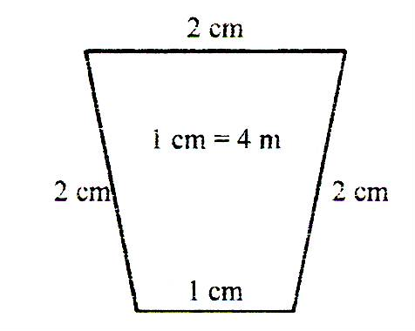

[A] 32 m [B] 28 m [C] 36 m [D] 24 m

1. A scale model of the Redwood Forest has a ratio of 1 in.: 40 ft. If the average tree was 220 feet tall, how tall would the scale model be?
2. Draw a diagram to solve: An elevator started on the 5th floor. It went up 7 floors, down 5 floors, up 9 floors, and down 4 floors. On what floor did the elevator finally stop?
3. A maple tree casts a shadow 45 ft long. At the same time, a 40 ft tall oak tree casts a shadow which is 60 ft long. What is the height of the maple tree? Make a diagram to solve this problem.
4. At the same time of day, a man who is 44.8 inches tall casts a 64-inch shadow and his son casts a 40-inch shadow. What is the height of the man’s son?

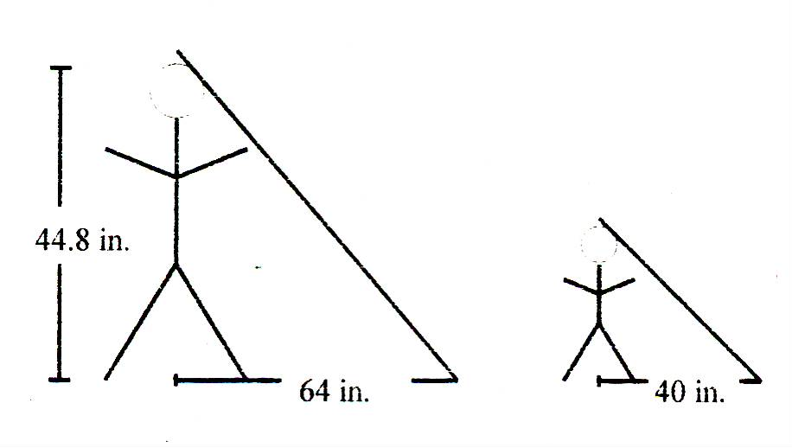

[A] 27 in. [B] 28 in. [C] 104 in. [D] 72.8 in.

1. Two ladders are leaning against a wall at the same angle as shown.

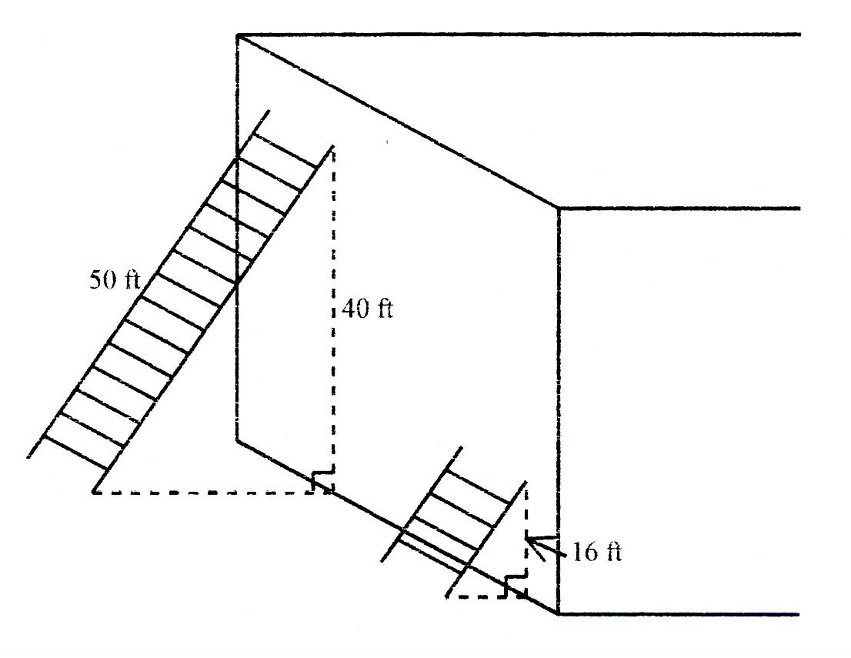

How long is the shorter ladder?

[A] 16 ft [B] 14 ft [C] 40 ft [D] 20 ft

1. A building is 200 feet tall, and casts a shadow of 37 feet into a nearby park. If a statue is in the park and casts a shadow of 11 feet, how tall is the statue?
2. Graph  with *D* (3, -2) and *E* (4, -4). Then graph the image of its dilation with a scale factor of 1.5.

