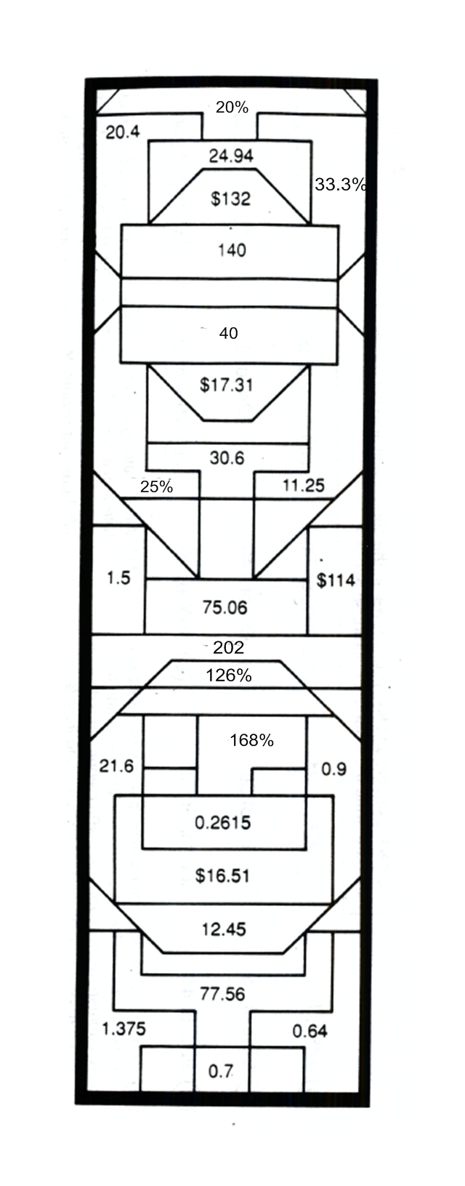
Name _______________________________ Date ____________________ Period _______
What Do Eskimos Use To Stick Their Houses Together?

Do the exercises below and find your answers in the rectangle. Shade in each area containing a correct answer. You will learn how to build an ice house. Show percent proportions on the back of this page. Use additional pieces of notebook paper if necessary.

1. 3 is what % of 15 2. 85% of 36

3. 84 is what % of 50 4. 3% of 720

5. 2.5% of 55 6. 18 is 45 % of what

7. 6.8% of 300 8. 70% of 110.8

9. 4% of 16 10. 7.5% of 12

11. 30% of 37.5 12. 15.12 of 12 is what %

13. 151.5 is 75% of what 14. 87.5% of 160

15. 70 is what % of 280 16. 12 is what % of 36

17. Fabio is a video salesman. On each sale, he earns a commission of 12%. One of his customers bought a TV for $550 and a VCR for $400. How much did he earn in commissions?

18. Robin bought a bow and 15 arrows at Nottingham Archery Supply. The total price was $254. In Nottingham there is a 6.5% sales tax. How much tax did Robin pay?

What Kind of Person Falls In Love With…?

1. What kind of person falls in love with a dairy farmer?

___ ___ ___ ___ ___ ___ ___ ___ ___ ___ ___ ___ ___ ___ ___ ___ ___ ___ ___ ___ ___ ___
8.4 6.12 48.6 56.3 21.87 140 8.4 128 21.87 16 6.12 2.24 46.5 750 2.24 8.4 24.7 720 16 39.6 39.6 75

___ ___ ___ ___ ___ ___ ___ ___ ___ ___
48.3 8.4 39.6 750 1.53 62.9 2.24 2.24 48.6 39.6

2. What kind of person falls in love with a poet?

___ ___ ___ ___ ___ ___ ___ ___ ___ ___ ___ ___ ___ ___ ___ ___ ___ ___ ___ ___ ___ ___
8.4 6.12 48.6 122.8 21.87 140 8.4 7.8 21.87 16 6.12 2.24 46.5 7.8 2.24 8.4 24.7 720 16 39.6 39.6 75

___ ___ ___ ___ ___ ___ ___ ___ ___
48.3 8.4 39.6 750 9.6 48.6 39.6 46.5 48.6

TO DECODE THE ANSWERS TO THESE TWO QUESTIONS:
Do each exercise and find your answer in the code. Each time the answer appears, write the letter of the exercise above it.

A
W
E
U
N
18% of 34 27% of 81 85% of 74 54% of 90 2% of 800

S
F
T
Y
O
70% of 69 4% of 56 6% of 140 12% of 625 62% of 75

V
B
R
90% of 44 9% of 17 48% of 20

H
M
Some doctors recommend that no more than 30% of a When training for a fight, Rocky tries to maintain a heart
person’s daily calories come from fats. Following this rate that is 80% of his maximum heart rate. Rocky has
recommendation, if you eat 2,400 calories in a day, what a resting heart rate of 60 and a maximum heart rate of
is the maximum number that should come from fats? 175 beats per minute. What is his training heart rate?

