Name _____________________________



|  |  |
| --- | --- |
| $y-2x=3$ | $5y+45=4x$ |
|  |  |

*m=_______________ m=_______________*

*y-*intercept:*_________ y-*intercept:*_________*

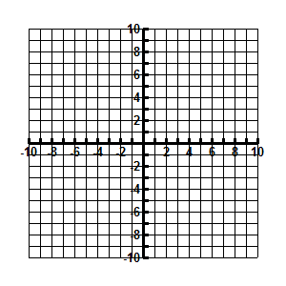

|  |  |
| --- | --- |
|  | 4. $Slope = -\frac{2}{3}, goes through (1, -5)$ |
|  |  |

*m=_______________ m=_______________*

*y-*intercept:*_________ y-*intercept:*_________*





**Start at the point. Then perform the slope that follows the point. Make sure you are connecting the points as you go. When you see the word STOP do NOT connect the next point.**

(-7, -9)

m = 2/-3

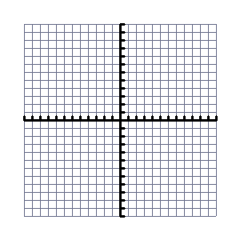m = 2/-1

m = 8/0

m = 2/2

m = 1/3

m = 0/10

m = -2/4

m = -4/2

m = -5/0

m = -3/-2

m = -1/-4

m = 0/-11

STOP

(-4, -8)

m =0/6

m = 3/3

m = -1/-3

m = 0/-6

m = 1/-3

m = -3/3

STOP

(-4,6)

m = 4/2

m = 2/2

m = -1/0

m = 0/2

m = -1/-1

m = -2/-1

m = -2/0

STOP

(-7,-1)

m = 4/2

m = -5/1

m = 1/-3

STOP

(5, 0)

m = 3/-2

m = -5/-1

m = 2/3

STOP

(0, -4)

m = 4/-1

m = -4/-1

m = 0/2

STOP