Riding Through Mixed Practice

- The graph below represents Sam and Austin’s jog in the park. The jogging trail in the park is 20 miles long.
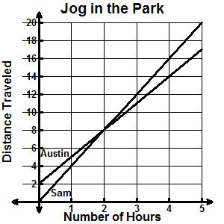
Location on Trail

Which of the following statements is true about Sam and Austin’s jog in the park?

    - Sam and Austin jog at the same rate.
    - Sam and Austin started jogging at the same location in the park.
    - After 2 hours, Sam and Austin are at the same place on the jogging trail.
    - Sam and Austin reach the end of the jogging trail at the same time.

- Pizza Express charges $8 for any medium pizza and $5 for delivery. Devine Pizza charges $10 for any medium pizza and has no delivery charge. Which pair of tables below correctly represent these situations?

A. |  | x | y |  | x | y
 |  | 2 | 21 |  | 1 | 11
 |  | 4 | 37 |  | 2 | 12
 |  | 6 | 53 |  | 3 | 13
 |  | 8 | 69 |  | 4 | 14
B. |  | x | y |  | x | y
 |  | 1 | 13 |  | 2 | 20
 |  | 3 | 23 |  | 4 | 40
 |  | 5 | 33 |  | 6 | 60
 |  | 7 | 43 |  | 8 | 80
C. |  | x | y |  | x | y
 |  | 2 | 18 |  | 1 | 11
 |  | 4 | 28 |  | 3 | 13
 |  | 6 | 38 |  | 5 | 15
 |  | 8 | 48 |  | 7 | 17
D. |  | x | y |  | x | y
 |  | 1 | 13 |  | 1 | 10
 |  | 2 | 21 |  | 2 | 20
 |  | 3 | 29 |  | 3 | 30
 |  | 4 | 37 |  | 4 | 40

3. Which of the following represents a linear relationship?

A. |  | 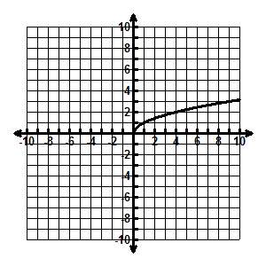 |  | C. |  | 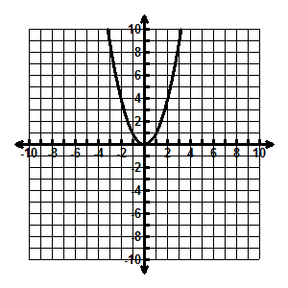
B. |  | 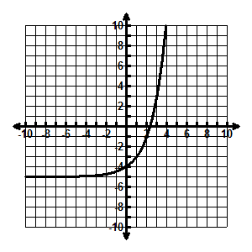 |  | D. |  | 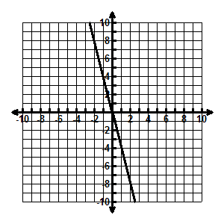

4. Which of the following tables represents a linear relationship?

A. |  | x | y |  | C. |  | x | y
 |  | 1 | -4 |  |  |  | -4 | 21
 |  | 2 | 2 |  |  |  | -3 | 14
 |  | 5 | 20 |  |  |  | -2 | 9
 |  | 9 | 44 |  |  |  | -1 | 6
B. |  | x | y |  | D. |  | x | y
 |  | 1 | 1 |  |  |  | 1 | 3
 |  | 4 | 2 |  |  |  | 2 | 9
 |  | 9 | 3 |  |  |  | 3 | 27
 |  | 16 | 4 |  |  |  | 4 | 81

5. Which of the following is NOT true about linear relationships?

A. The table of values has a constant rate of change.
B. All linear relationships have a constant of proportionality.
C. The graph can go through the origin.
D. The graph of a linear relationship is always a line.

6. Which of the following does NOT represent a linear relationship?

A. |  |  |  | C. |  | 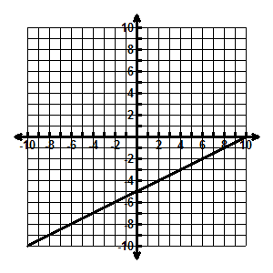
B. |  | 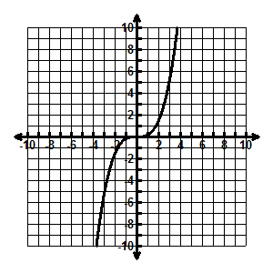 |  | D. |  | 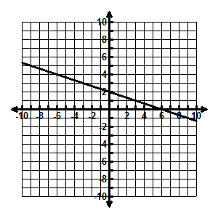

7. Which of the following tables does NOT represent a linear relationship?

A. |  | x | y |  | C. |  | x | y
 |  | -7 | 2.5 |  |  |  | -6 | -2
 |  | -4 | 4 |  |  |  | -3 | -1
 |  | -3 | 4.5 |  |  |  | 3 | 1
 |  | 1 | 6.5 |  |  |  | 6 | 2
B. |  | x | y |  | D. |  | x | y
 |  | -1 | 2 |  |  |  | -2 | -11
 |  | 0 | 1 |  |  |  | -1 | -9.5
 |  | 1 | 2 |  |  |  | 3 | -3.5
 |  | 2 | 5 |  |  |  | 5 | -0.5

8. Look at the statements below.

- The graphs of all linear relationships are a line.
- The graphs of all linear relationships go through the origin.
- The tables of all linear relationships have a constant rate of change.
- The tables of all linear relationships contain the point (0, 0).

Which of the statements above are true?

A. I and III only C. II and IV only
B. I, II, and III only D. I, II, III, and IV

