Describe how each of the following are represented (graph, ordered pairs, mapping, table)
1

2

3

4

6

2

- _________________________:

Domain:__________________

Range:___________________

INPUT | 1 | 2 | 3
OUTPUT | 2 | 4 | 6
- __________________________:

Domain:__________________

Range:___________________

3.___________________________:

Domain:__________________

Range:___________________

4. __________________________: {(1,2), (2,4), (3,6)}
Domain:__________________

Range:___________________

Now, create a rule for the above function:

Represent the following function as a map, graph, ordered pair, and table

y = x+2

Domain 1, 2, 3, 4

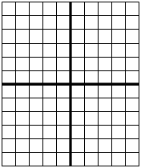

Create your own function…….

