Name _______________________________ Date ___________ Period __________

j0240323





**INDEPENDENT EVENTS:**

Independent events are the occurrence of one event that has no effect on the probability of the second event.

**Probability of Independent Events**

Probability of both events = probability of first event x probability of second event

P(A and B) = P(A) x P(B)

You will roll a number cube twice. Find the probabilities below.

6.) P(1, then 5) = _____ x _____ = 7.) P(1, then 1) = _____ x _____ =

8.) P(3, then odd) = _____ x _____ = 9.) P(odd, 5) = _____ x _____ =

You will toss a coin and roll a number cube. Find the probabilities below.

10.) P(heads, 4) = _____ x _____ = 11.) P(heads, even) = _____ x _____ =

12.) P(tails, 7) = _____ x _____ = 13.) P(tails, not 5) = _____ x _____ =



**Dependent events are the occurrence of one event that does have an effect on the probability of the second event.**

**Probability of Dependent Events**

Probability of both events = probability of first event x probability of second event after first event

P(A then B) = P(A) x P(B after A)

Liz placed the seven cards shown below in a box. She draws one at random and **does not** **replace it.** She then draws another card. Find the probabilities.

**B**

**A**

**N**

**A**

**1**

**N**

**A**

**S**

**j0232913**

1.) P(N, N) = _____ x _____ = 2.) P(B, B) = _____ x _____ =

3.) P(A, N) = _____ x _____ = 4.) P(S, A) = _____ x _____ =

At her party Sherry had grab bags as party favors. When a person selected a grab bag, the item chosen was **not replaced**, they got to keep their item! The chart shows how many bags contained each prize. What is the probability that…

|  |  |
| --- | --- |
| **PRIZE** | **# OF BAGS** |
| IPOD | 6 |
| PSP | 5 |
| Blue Ray | 4 |

5.) The first two bags selected each had an IPOD?

****_____ x _____ =

6.) The first two bags selected each had a PSP?

_____ x _____ =

7.) The first bag selected had an IPOD and the second bag had a Blue Ray?

_____ x _____ =

8.) The first bag selected had a PSP, the second bag selected had an IPOD, and the third

bag selected had a Blue Ray?

_____ x _____ x _____=

Jodi has a bag of candy bars and she decides to share with her friends. When they take a candy bar out of the bag they get to keep it. The chart shows how many candy bars are in the bag. What is the probability that…

|  |  |
| --- | --- |
| **Candy bar** | **# of Candy Bars** |
| Kit Kat | 3 |
| Snickers | 6 |
| Hershey Bar | 2 |
| M&M’s | 4 |
| Butterfinger | 5 |

9.) The two candy bars selected would be Snickers?

_____ x _____ =

j030548710.) The first candy bar will be M&M’s and the second will be a Butterfinger?

_____ x _____ =

11.) The first candy bar will be a Hershey Bar, the second will be a Kit Kat, and the third will be a Snickers?

_____ x _____ x _____=

12.) Fiona has a bag containing 6 red, 8 blue, 5 green, 9 yellow, and 2 white marbles that are all the same size and shape. What is the probability of randomly choosing a white marble on the first pick, without replacing it, and then randomly choosing a green marble on the second pick?

A.  C. 

B.  D. 

j035028513.) Nicole has a bag with 4 watermelon, 3 green apple, 6 cherry, and 7 grape suckers that are all the same size and shape. What is the probability of randomly choosing a grape sucker on the first pick, without replacing it, and then choosing a watermelon sucker on the second pick?

A.  C. 

B.  D. 

14.) Sharon played an electronic game. There were 15 questions, of which she answered 3 incorrectly. At this rate, how many questions should Sharon expect to answer incorrectly if she answers a total of 135 questions?

A. 45 C. 9

B. 27 D. 5

15.) The probability of a table-tennis ball being defective is . About how many balls would be defective in a case of 725 table-tennis balls?

A. 1 C. 73

B. 7 D. 80

16.) The results of a random survey showed that 42 out of 80 people plan to vote for Mr. Vu for city council. Which is the best prediction of the total number of votes he will receive if 2,000 people vote?

A. 25 C. 120

B. 50 D. 1,000

**INDEPENDENT vs. DEPENDENT EVENTS:**

Read each situation and decide if the events described are independent (not related) or dependent (related).

17.) A number cube is rolled twice __________________

18.) Choose one card, replace it, and choose another card __________________

19.) Choose one card, do not replace it, and choose another card __________________

20.) A student spins a spinner and chooses a Scrabble tile __________________

Use these cards to answer the following questions.

**R**

**1**

**R**

**2**

**R**

**3**

**Y**

**1**

**1**

**Y**

**2**

**G**

**1**

**G**

**2**

**B**

**1**

1.) P(R) = 2.) P(R and 2) = 3.) P(5) =

4.) P(Y) = 5.) P(R or 2) = 6.) P(not R) =

7.) P(1 or 2 or 3) = 8.) P(B or 2) = 9.) P(G and 3) =

**Scenario: There is a person in your class who has a bag with 24 M & M’s. This person has 6 red, 4 orange, 7 yellow, 3 purple, and 4 green.**

10.) Find the following probabilities if you were to draw from his bag and replace M & M’s

after each draw.

j0290087

a.) P(green or red) = b.) P(red) =

c.) P(purple and orange) = d.) P(blue) =

11.) Trinh has 2 quarters, 1 dime, 2 nickels, and 1 penny in his pocket. Which list shows all

the possible unique outcomes if Trinh chooses 3 coins at one time from his pocket?

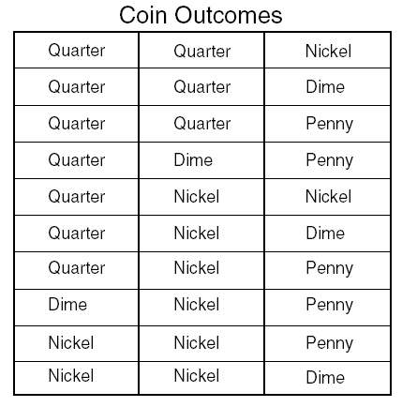

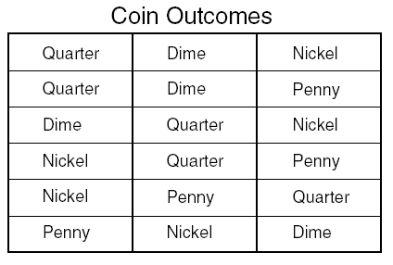F H

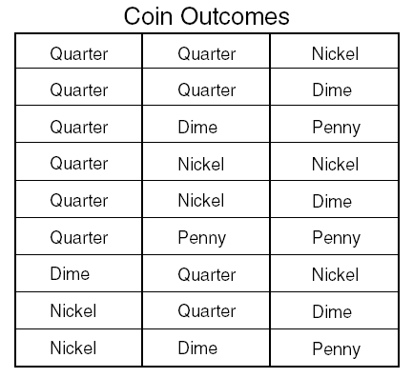

G J

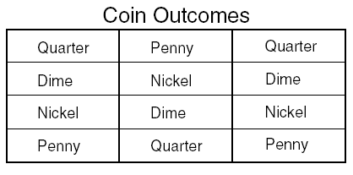

12.) A spinner and a fair number cube are used in a game. The spinner has an equal

chance of landing on 1 of 4 colors: red, purple, blue, or green. The faces of the cube

are labeled 1 through 6. What is the probability of a player spinning the color red and

then rolling a 5 or 6?

F.  H. 

G.  J. 

13.)The probability of a table-tennis ball being defective is . About how many balls would **not** be defective in a case of 725 table-tennis balls?

A. 10 C. 653

B. 725 D. 73

14.) Lily played a game where she spun each of the spinners shown below once.

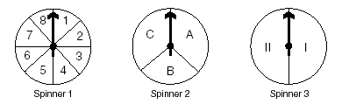

Which choice shows all the possible unique combinations of an odd number on Spinner 1, an A or a B on Spinner 2, and a II on Spinner 3?

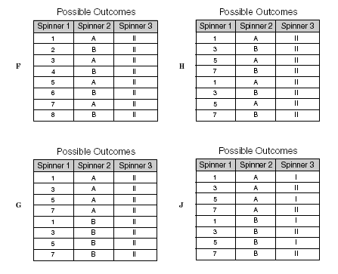

15.) Fiona has a bag containing 6 red, 8 blue, 5 green, 9 yellow, and 2 white marbles that

are all the same size and shape. What is the probability of randomly choosing a white

marble on the first pick, replacing it, and then randomly choosing a green marble on the second pick?

A.  C. 

B.  D. 

16.) Fidel tosses four fair coins. What is the probability that all four coins will land heads up?

A.  C. 

B.  D. 