Name:______________________________________ Date:______________________ Period:_______
Proportional vs. Non Proportional

1. $y=2x+4$
x | 2x+4 | y |  | (x, y)
-2
-1
0
1

Is the equation proportional or non proportional?

2. $y=-3x$
x | -3x | y |  | (x, y)
-1
0
1
2

Is the equation proportional or non proportional?

For #3 – 5, create a table on the back of this page including the process column. Graph each equation. Label each proportional or non proportional.
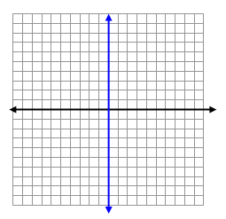
3. $y=\frac{x}{2}$ 4. $y=3x$ 5. $y=1-x$

