Name ________________________________________ Date__________________
Identifying and Evaluating Functions
Read each situation carefully and determine the independent variable and dependent variable.
- Circle or highlight the independent variable, and
- Write a sentence giving the relationship between the two variables using either “depends on” or “is a function of.”

- The amount of money Mary earns in one week and the number of hours she works in a week.

- The size of a ball and the number of balls that will fit in a box.

- The grade in Algebra I and the amount of time you spend doing your homework.

- How long it takes you to do your Algebra I homework and the number of problems you were assigned.

Determine whether each relation is a function. State yes or no and justify your response.
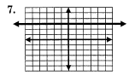
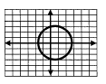
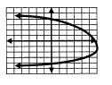
5. 6. 7.

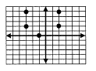
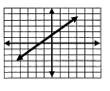
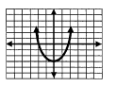
8. 9. 10.

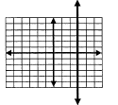
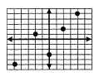
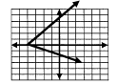
11. 12. 13.

14. 15. 16.
4
6
8
–2
5
3
–1
4
8
10
10
11
–8
–6
2
0
4
8
9

17. {(2,4), (3,5), (4,6), (5,8)} 18. {(1,5), (1,7), (1,–5), (1,–7)}

19. {(–1,4), (0,4), (1,4), (2,4)} 20. {(2,5), (3,2), (5,0), (3,–2)}

Input | 1 | 3 | 5 | 7
Output | 4 | 2 | 0 | –2
X | –1 | 0 | 2 | –1
y | 1 | 0 | –1 | –3
21. 22.

x | f(x)
2 | 5
3 | 4
4 | 4
5 | 2
Input | Output
–2 | –5
–1 | 6
1 | 4
11 | 6
Cost | Hour
1 | 25.00
2 | 30.75
3 | 36.50
4 | 42.25
23. 24. 25.

Evaluate each function.
Given: $f\left(x\right)=-3x+8$ $g\left(x\right)=x^{2}-1$ $h\left(x\right)=\sqrt{x-6}$ $m\left(x\right)=\frac{3}{4}x+2$

26. $f(2)$ 27. $g(4)$ 28. $g(-2)$ 29. $h(15)$

30. $m(-8)$ 31. $m\left(\frac{1}{3}\right)$ 32. $h(g\left(4\right))$ 33. $f(k+1)$

