Name __________________________________ Date__________________ Period_____

**Approximating Square Roots Practice**

*For #1 – 6, use the number line below to answer the following questions.*

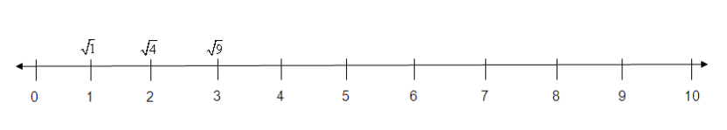

**1.** The $\sqrt{29}$ falls between ______ and ______. **2.** The $\sqrt{89}$ falls between ______ and ______.

**3.** Which of the following values falls between $\sqrt{64}$ and $\sqrt{81}$? (circle one)

0.**8 6.4 8.75 9.1**

**4.** Which square root is closest to 7? (circle one)

$\sqrt{8}$ $\sqrt{14}$ $\sqrt{46}$ $\sqrt{78}$

*Find two consecutive whole numbers to make the statements true.*

**5.** _______ <  < _________ **6.** _______ <  < _________

*Estimate each square root and place them on the number line below.*



**7.**  **8.** 

Identify the following numbers as Real, Rational, Integers, Whole Numbers, and/or Irrational.

9. 15 _____________________________________________________________________

10. _______________________________________________________

11. –49 ____________________________________________________________________

12. 0.25 ___________________________________________________________________

13. ___________________________________________________________________

14. –12.97 _________________________________________________________________