Name:_________________________________ Period:____________ Date:_______________
Review of compare and order, and multiple representations
- Given the following sequence 20, 15, 10, 5, 0, … make a table and the equation. Also solve for when n = 10. Is this proportional or non-proportional? Explain?
- Randall has some left over canisters marked with the following numbers -15%,- $\frac{3}{5}$ , -0.5, -0.8, and - $\frac{1}{10}$ . How would Randall arrange them in descending order?

- Given the expression 6n – 2, what would be the first 5 terms of the sequence?
- Mr. Tucker is trying to figure out his electric bill. He knows the equation for his plan is y = .25m where m represents the number of Kilowatt hours he uses, and y represents the total cost of his bill.
  - Is this equation proportional or non-proportional? Explain why?

  - What would he have to pay for his bill, if he used 200 Kilowatt hours?

- Given the following set of numbers 411%, 4 $\frac{1}{10}$, 4.055, 4 $\frac{1}{9}$ , what is the order of the numbers from least to greatest?

- The overall widths of some wooden boards are 15 $\frac{7}{8}$ in, 15 $\frac{8}{9}$ in, 15 $\frac{4}{5}$ in, and 16.9 in. Order the widths of the wooden boards in descending order.

7. The cost of a music club membership is a $10 per month and a instrument rental fee of $15. Write an equation to represent y, the amount a member paid to the music club for x number of months?

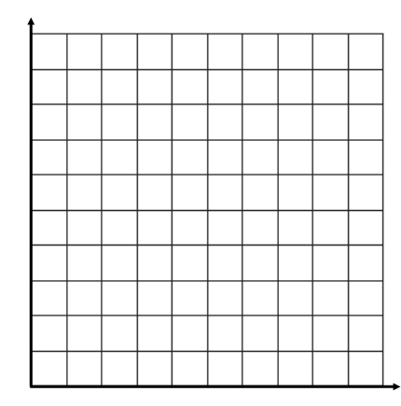
Variables: x = _________________
100
y = _______________
80
Equation: _________________
60
x | Process: | y
1
3
7
9

40
20
0 1 2 3 4 5 6 7 8 9 10

