Name:__________________________ Period:___________

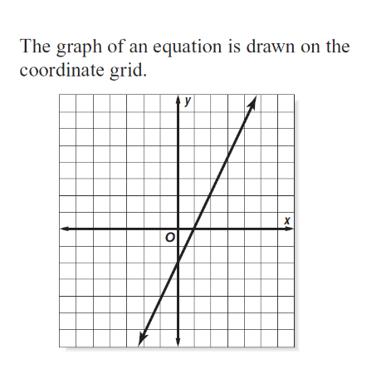Reading Representations and making predictions

Create a table for the graph.

1. Given the following graph. Answer the questions

below.



1. Is the graph proportional or non-proportional?

Explain.

1. If I burned 1,000 calories, then about how many

miles did I walk?

1. About how many calories did a person burn, if they walked for 4 miles?
2. If a person burned 700 calories, then how many

miles did that person walk?

3) Christopher determined that the equation c = 12m + 14 can be used to find *c*, the monthly charges on his cell phone bill for *m* minutes used. Find the monthly charge for 240 minutes of cell phone use.

Name:__________________________ Period:___________

Reading Representations and making predictions

1)

Create a table for the graph.

1. Given the following graph. Answer the questions

below.



1. Is the graph proportional or non-proportional?

Explain.

1. If I burned 1,000 calories, then about how many

miles did I walk?

1. About how many calories did a person burn, if they walked for 4 miles?
2. If a person burned 700 calories, then how many

miles did that person walk?

3) Christopher determined that the equation c = 12m + 14 can be used to find *c*, the monthly charges on his cell phone bill for *m* minutes used. Find the monthly charge for 240 minutes of cell phone use.