Name:_________________________ Period:___

Scatter plot, histograms, box and whiskers, and measure of central tendency and range

1. The scatter plot below shows the cost of phone calls Betsy made to her brother overseas in relation to the number of minutes per phone call. Based on the information in the scatter plot, which statement is a valid conclusion.
2. As Betsy made more phone calls, the cost of the phone calls increased.
3. As Betsy made fewer phone calls, the cost of the phone calls decreased.
4. As Betsy decreased the number of minutes on the phone, the number of phone calls decreased.
5. As Betsy increased the number of minutes on the phone, the cost of the phone calls increased.
6. A retail store has total sales of $436, $650, $530, $500, $650, $489, and $423 last week. Which measure of data would make the store’s sales last week appear the most profitable?
7. Mode B. Median
8. Mean D. Range
9. A store manager collects data showing the number of times each brand of soap is purchased in his store. Which measure of data shows which brand he sells the most?
10. Median B. Mean

C. Mode D. All of the above

1. Which statement about the data represented by the box-and-whisker plot is not true?

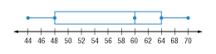

1. The inter-quartile range is 16
2. The data in the second quartile is less spread out than the data in the third quartile.

C. The median is 60.

D. The range is 26.

1. The frequency table shows the ages of the people attending a family reunion. Which histogram correctly and completely shows the data?

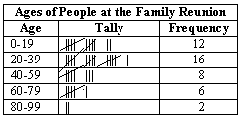

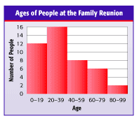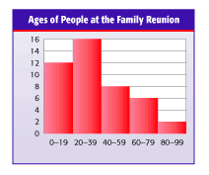

A. C.

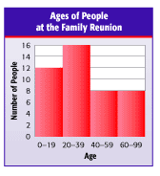

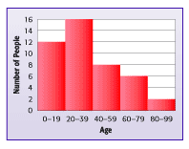B. D.

6) Which type of relationship does the scatter plot show?



1. Both positive and Negative
2. Positive
3. Negative
4. No relationship

7) What is the volume of the square pyramid?

A. 45 ft3

B. 31.5 ft3

C. 22.5 ft3

D. 15 ft3

**Given the following box-and-whiskers plot about the number of questions students got right on a test out of 16. Answer the following questions for #8-10.**



8) Find the inter-quartile range of the box-and-whiskers plot?

9) What percent of students answered at least 9 questions correct?

10) What was the median score of this test?

11) Which of the following is not true of a circle graph?

A. A circle graph must total 100%

B. A circle graph may have percentages or numeric values on the graph

C. A circle graph is best used for surveys and budgets

D. A histogram can always be used to replace a circle graph

12) What is the total surface area of the triangular prism?

A. 160 m2

B. 90 m2

C. 184 m2

D. 240 m2

**For Questions 13 and 14, use the results of a survey of 60 people shown at the right.**

13. What is the probability that a person’s favorite juice is apple?

14. How many people would say their favorite juice is Grapefruit if 300 people were surveyed?

15. A store is recording the data of the biggest 6 video games sold in a month. What would be the best way to present the data?

A. Histogram B. Line plot C. Bar Graph D. Box-and-Whiskers

16. What type of trend is this graph showing?



17. Using the graph from question 16, what would the relationship be in words?

18. What is the surface area of the following rectangular prism?

