Given | Find | Predict or Explain | Discuss
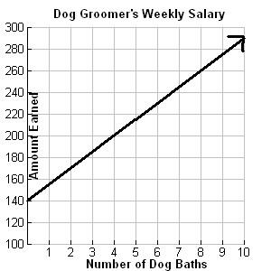 | The equation which represents the Dog Groomer’s Weekly Salary. | Prediction Question:  How many dogs would the groomer need to bathe in a week to earn at least $400? | What does the y-intercept represent in this situation?  If the amount that the groomer earns per bath is increased, what would happen to the graph?
Alamo Rent a Car is advertising a new rental car fee. They plan to charge all customers a $35 gas fee plus $50 per day for luxury car rentals. | The graph that represents the Alamo Rental Car Fee for luxury cars.  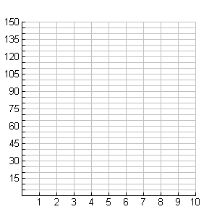 | Budget Rent a car plans to advertise a similar program where customers pay a $50 gas fee plus $45 per day for luxury car rentals.  Prediction Question:  If you plan to rent a luxury car for 7 days, which company offers the best rate? | Does your graph support your answer to the predict question?  What does the gas fee represent in this situation?  Which company offers the best rate if the number of days is reduced to 3?  If you decide to rent a luxury car from Budget, what is the cost for renting the car for 12 days?
The table below shows a college student’s savings account balance during his freshman year of college.  Months Savings Account Balance  2 $1500  4 $1000  6 $500  Note:  The college student will not make any deposits into his account throughout the year. The account will continue to decrease at the same rate throughout the year. | Describe in words this college student’s savings account.  Then, write an equation which represents his account balance. | Explain:  The meaning of the y-intercept in this situation.  The meaning of the x-intercept in this situation.  The meaning of slope in this situation. | Will the student have enough money in his savings account to make it through an entire year of college? (12 months)  What is a reasonable domain for this situation?
The equation that represents the initial fee and cost per shirt for two t-shirt companies is shown below:  Company A: $y=5.25s+25$  Company B: $y=6.50s+15$ | Create a table to prove which company has the best deal if you order 5, 10, or 15 shirts. | Explain:  How does the graph of Company B’s cost compare to the graph of Company A’s cost?  Prediction Question:  What is the maximum number of t-shirts you can purchase for $125? Which company would you use? | Which company’s initial fee is higher?  Which company has the lower price per shirt?  If you created a third company that charged $7 per shirt, what initial fee would you need to charge to compete with Company A and B?
The graphs below show the descent of two scuba divers to the ocean floor.  Diver A:  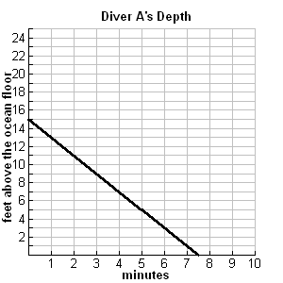  Diver B:  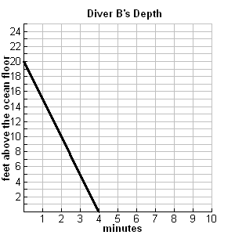 | Find the equation for each diver’s depth after m minutes. | Explain:  What does the x-intercept represent in this situation?  Which Diver has the fastest rate of descent?  Prediction Question:  How long will it take Diver A to get to the ocean floor if his starting depth changes to 20 and his rate of descent stays the same?  How long will it take Diver B to get to the ocean floor if her starting depth stays the same but her rate of descent changes to 4 feet minute? | If the y-intercept is increased and the rate of descent stays the same for each Diver, what will happen in the situation?

