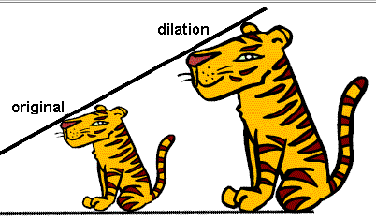**Dilations**

A is a transformation in which a figure and its image are similar.

The number that is multiplied by the dimensions of the original figure to reduce or enlarge it is called the __________.

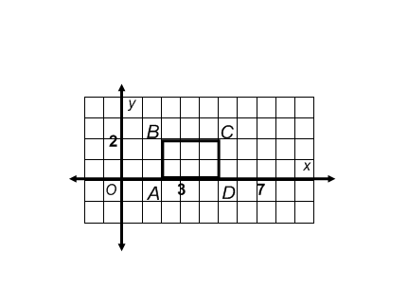

|  |  |  |
| --- | --- | --- |
| **Pre Image** | **Process** | **Image** |
|  |  |  |
|  |  |  |
|  |  |  |
|  |  |  |

Example One: List the ordered pairs for rectangle ABCD then enlarge it by a scale factor of 2. List the new ordered pairs.

Look at the new ordered pairs. Is this an enlargement or reduction?

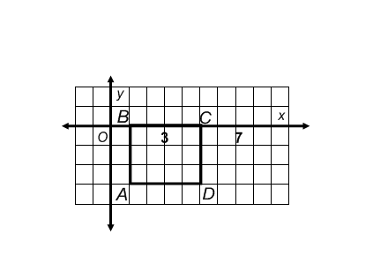Is this an enlargement or reduction?

List the ordered pairs for rectangle ABCD then shrink it by a scale factor of List the new ordered pairs.

|  |  |  |
| --- | --- | --- |
| **Pre Image** | **Process** | **Image** |
|  |  |  |
|  |  |  |
|  |  |  |
|  |  |  |

Look at the new ordered pairs. Is this an enlargement or reduction?

If the scale factor is **_________________________**, the picture **_________________**.

If the scale factor is **_________________________**, the picture **__________________**.

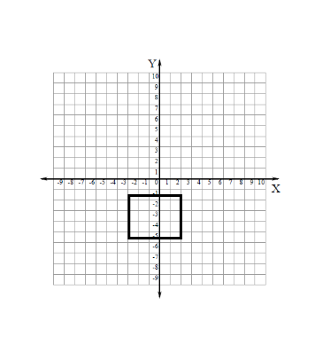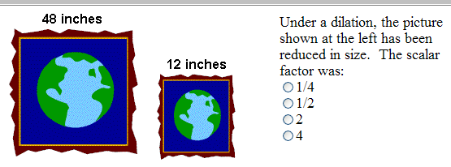

The graph for rectangle ABCD is shown below. If it is dilated by a scale factor of 3, what are the new coordinates?

|  |  |  |
| --- | --- | --- |
| **Pre Image** | **Process** | **Image** |
|  |  |  |
|  |  |  |
|  |  |  |
|  |  |  |

