**Choosing the Rule**

The side lengths and perimeters of some regular polygons are shown in the table below. Which expression can be used to find the perimeter of a similar polygon with a side length of *n* units?

A. 

|  |  |
| --- | --- |
| Side Length (n) | Perimeter  (y) |
| 4 | 12 |
| 5 | 15 |
| 7 | 21 |
| 9 | 27 |
| n |  |

B. 

C. 

D. 

The table below shows about how many people live in an area of square miles.

|  |  |
| --- | --- |
| Square Miles (n) | Number of People (y) |
| 12 | 960 |
| 20 | 1600 |
| 35 | 2800 |
| 40 | 3200 |
| n |  |

Which expression can be used to find the number of people that would occupy an area of *n* square miles?

A.  C. 

B.  D. 

Which equation can be used to the find the number of ounces, *y*, in *x* cups?

|  |  |  |  |  |
| --- | --- | --- | --- | --- |
| Cups (*x*) | 1 | 2 | 3 | 4 |
| **Ounces (*y*)** | 8 | 16 | 24 | 32 |

A. *y* = 8*x*

B. *y* = *x* + 8

C. 

D. *x* = 8*y*

**Building the Table**

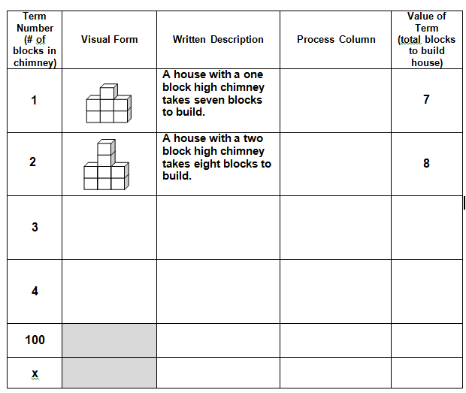

What is the arithmetic sequence represented

by the table?

______ , ______ , ______ , ______ , _____ , ______

Which expression can be used to find the value

of any term in the table above?

* 1. 3n + 4 C. 6n + 1

B. n + 6 D. 2n + 4

How many blocks would be needed if there were 11 block in the chimney? _______

If 26 blocks were used, how many blocks are in the chimney?

* 1. 16 C. 10
  2. 20 D. 9

If the rule for the pattern is 2(x) +1, how many blocks will be in the figure on the 25th day?

Day 1

Day 2

Day 3

A. 26 C. 50

B. 49 D. 51

Write a process table for the following expressions.

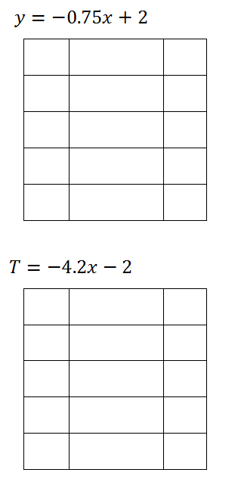

|  |  |  |
| --- | --- | --- |
|  |  |  |
|  |  |  |
|  |  |  |
|  |  |  |
|  |  |  |

|  |  |  |
| --- | --- | --- |
|  |  |  |
|  |  |  |
|  |  |  |
|  |  |  |
|  |  |  |

Which expression can be used to find the *n*th term in this sequence? Build a process table.

What is the sequence represented by this situation? ___, ___, ___, ___,

The sequence is going up / down by _____. That is the number if front of the n.

Eliminate _________.

A.  C. 

B.  D. 

Which equation best represents the relationship between *x* and *y* in the table below?

|  |  |
| --- | --- |
| ***x*** | ***y*** |
| 8 | 1 |
| 12 | 3 |
| 18 | 6 |
| 20 | 7 |

A.  C. 

B.  D. 

Which equation best represents the relationship between *x* and *y* in the table below?

|  |  |
| --- | --- |
| ***x*** | ***y*** |
| 6 | 1 |
| 10 | 3 |
| 16 | 6 |
| 18 | 7 |

A.  C. 

B.  D. 

If the pattern continues, how many blocks will be in the figure on day 25? Hint: Build a table.

Day 1

Day 2

Day 3

A. 26 C. 50

B. 49 D. 51