Name: __________________________________ Date: ________________ Period: ______

**8th Grade MATH Second Semester Review**

1. A bicycle courier in downtown New York City records the distance she travels and the time for each delivery she makes in a day. Draw a scatter plot on the graph to represent this relationship. Does it have a trend? ____________ If yes, is it a positive or negative trend? ______________________

|  |  |  |  |
| --- | --- | --- | --- |
|  |  |  |  |
|  |  |  |  |

2. Jennifer collected data on the ages and heights of a random sample of 1st, 5th, and 10th grade students. She plotted the data points on a scatterplot. What relationship between age and height is likely seen on the scatterplot? _____________________ Draw a sketch of what her scatterplot probably looked like. Be sure and label your axes.

|  |  |  |
| --- | --- | --- |
|  |  |  |
|  |  |  |

3. The graph shows the relationship between a person’s height and weight.

|  |  |
| --- | --- |
| Weight (kilograms) |  |
|  | Height (meters) |

Describe the relationship between height and weight: As ____________________ increases, the ____________________________________.

What is the correlation of the graph? _________________________

What would be a reasonable weight for someone 1 meter in height? ________________________

What would be a reasonable height for someone who weighs 40 kilograms? __________________

4. Sketch an example of a scatterplot with a positive correlation, a negative correlation, and one with no correlation.

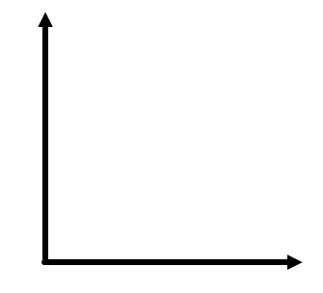  

Positive correlation Negative correlation No correlation

5. The table below shows the lengths of several sailboats and their cost in thousands of dollars.

|  |  |
| --- | --- |
| **Cost of Sailboats** | |
| **Length**  **(feet)** | **Cost**  **(thousands of dollars)** |
| 27 | 94 |
| 17 | 52 |
| 25 | 68 |
| 30 | 120 |
| 18 | 60 |
| 26 | 87 |
| 35 | 143 |

The cost for a 22 foot sailboat would be between what two costs?

6. Mary’s distance in feet as she walks away from the pool is represented below.

|  |  |
| --- | --- |
| **Table** | **Graph** |
| |  |  | | --- | --- | | **Time (seconds)** | **Distance (feet)** | | 0 | 5 | | 3 | 11 | | 1 | 7 | | 12 | 29 | | 2 | 9 | | [image] |

**Does this represent a linear relationship? Why or why not?**

7. Label the following as either a **function** or **not a function**. Explain why each is or is not a function.

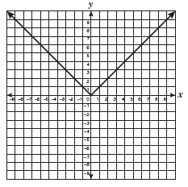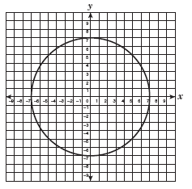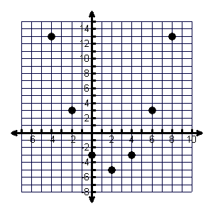

|  |  |  |  |
| --- | --- | --- | --- |
|  | [image] |  | [image] |
|  |  |  |  |
|  |  |  |  |
|  |  |  |  |

|  |  |  |  |  |  |  |  |  |  |  |  |  |  |
| --- | --- | --- | --- | --- | --- | --- | --- | --- | --- | --- | --- | --- | --- |
|  | {(-2, 4), (3, 4), (5,4)} |  | |  |  | | --- | --- | | ***x*** | ***y*** | | 9 | -3 | | 4 | -2 | | 4 | 2 | | 9 | 3 | |
|  |  |  |  |
|  | [image] |  | 0  5  1  -2  3  1 |

8. Michael, Holly, and Joey were each assigned to find the trend line for their data.

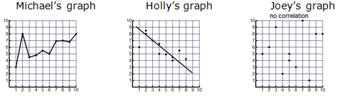

Which student/students completed the assignment correctly? _________________________ Why?

9. Label the following tables as either **linear** or **nonlinear**. If linear, write the equation that represents the table.

|  |  |  |  |  |  |  |  |  |
| --- | --- | --- | --- | --- | --- | --- | --- | --- |
|  |  | ***x*** | ***y*** |  |  |  | ***x*** | ***y*** |
|  |  | 1 | -4 |  |  |  | -4 | 21 |
|  |  | 2 | 2 |  |  |  | -3 | 14 |
|  |  | 5 | 20 |  |  |  | -2 | 9 |
|  |  | 9 | 44 |  |  |  | -1 | 6 |
|  |  |  |  |  |  |  |  |  |
|  |  |  |  |  |  |  |  |  |
|  |  | ***x*** | ***y*** |  |  |  | ***x*** | ***y*** |
|  |  | 1 | 1 |  |  |  | 1 | 3 |
|  |  | 4 | 2 |  |  |  | 2 | 9 |
|  |  | 9 | 3 |  |  |  | 3 | 27 |
|  |  | 16 | 4 |  |  |  | 4 | 81 |
|  |  |  |  |  |  |  |  |  |

10. Draw an example of a linear relationship and a nonlinear relationship.

 

Linear Nonlinear

11. Draw an example of a proportional relationship and a non-proportional relationship.

 

Proportional Non-proportional

12. What are the solutions to each of the systems graphed below?

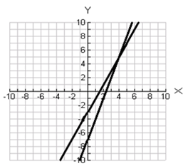

What is the intersection point? _________ What is the intersection point? ________

So the solution is __________. So the solution is __________.

13. Howard recorded the distances he traveled while training for a bike race in the table below.

|  |  |
| --- | --- |
| **Time in hours, *x*** | **Total Distance Traveled in miles, *y*** |
| 1.5 | 30 |
| 3 | 60 |
| 4.5 | 90 |
| 6 | 120 |

What is the slope of the line which represents the relationship shown in the table? ___________

Does this represent a direct variation? _________ Why/why not?

14. James recorded the distances he traveled while training for a bike race in the table below.

|  |  |
| --- | --- |
| **Time in hours, *x*** | **Total Distance Traveled in miles, *y*** |
| 3 | 135 |
| 4.5 | 157.5 |
| 6 | 270 |
| 7.5 | 337.5 |

What is the slope of the line which represents the relationship shown in the table? ___________

Does this represent a direct variation? _________ Why/why not?

15. Circle all of the equations that represent a **direct variation**. Explain why each equation is or is not a direct variation.

|  |  |  |  |
| --- | --- | --- | --- |
|  |  |  |  |

|  |  |  |  |
| --- | --- | --- | --- |
|  |  |  |  |

|  |  |  |  |
| --- | --- | --- | --- |
|  |  |  |  |

16. Write the equation that represents the data in the table below.

|  |  |  |  |  |  |  |
| --- | --- | --- | --- | --- | --- | --- |
| ***x*** | –3 | –1 | 1 | 3 | 5 | 7 |
| ***y*** | –9 | –7 | –5 | –3 | –1 | 1 |

17. Write the equation for the linear relationship graphed below.

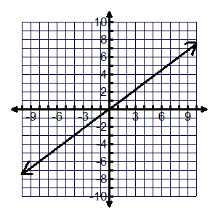

Slope: ____________

*y*-intercept: ______________

Equation of the line in slope-intercept form: _____________________

18. Is the data in the table below **linear** or **non-linear**? Why?

|  |  |  |  |  |  |  |
| --- | --- | --- | --- | --- | --- | --- |
| ***x*** | -2 | -1 | 0 | 1 | 2 | 3 |
| ***y*** | 4 | 2 | 0 | -2 | -4 | -6 |

19. Find the slope (rate of change) for each of the following…

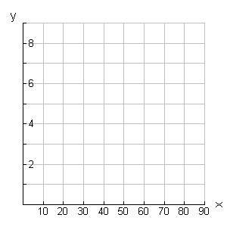

●

●

●

●

●

●

●

●

|  |  |
| --- | --- |
| Size of Lawn  (square feet) | Fertilizer Required  (pounds) |
| 50 | 0.5 |
| 100 | 1.0 |
| 200 | 2.0 |

m = _________

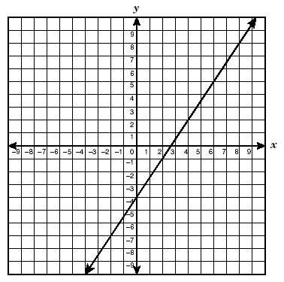 m = ________



m = _________ m = _________

20. The tables below are examples of linear relationships.

|  |  |  |  |  |  |  |
| --- | --- | --- | --- | --- | --- | --- |
| ***x*** | –5 | –1 | 3 | 7 | 11 | 15 |
| ***y*** | –7 | –5 | –3 | –1 | 1 | 3 |

Write an equation for the data in the table. ________________

|  |  |  |  |  |  |  |
| --- | --- | --- | --- | --- | --- | --- |
| ***x*** | –2 | 0 | 2 | 4 | 6 | 8 |
| ***y*** | –8 | –5 | –2 | 1 | 4 | 7 |

Write an equation for the data in the table. ________________

21. Ryan’s lunch account began with $60 and he spends $3.75 per day on his lunch. Roger’s lunch account began with $16 and he spends $0.60 per day on his lunch. Write and equation that could be used to solve for how many day, *d*, Ryan and Roger will have **the same amount** of money in their lunch accounts.

22. Rebecca’s lunch account began with $32 and she spends $1.75 per day on her lunch. Jessica’s lunch account began with $26 and she spends $0.30 per day on her lunch. Write an equation that could be used to solve for how many day, *d*, Rebecca and Jessica will have **the same amount** of money in their lunch accounts.

23. A local tanning salon offers a monthly membership for $40. As a member, customers can buy tanning sessions at a reduced rate of $25. Non-members pay $35 for a tanning session. Write an inequality that could be used to determine the number of tanning sessions, *t*, that an individual could purchase per month for membership to be **less than or equal to** the cost of a non-member?

24. A local gym offers a monthly membership for $85. As a member, customers can buy a personal trainer session at a reduced rate of $50. Non-members pay $75 for a session. Which inequality could be used to determine the number of sessions, *s*, that an individual could purchase per month for membership to be **less than or equal to** the cost of a non-member?

25. Amber and Sydney begin saving money to purchase a new television. Both girls receive an allowance and will place the entire allowance in their savings. Sydney already has $80 saved and Amber has $45 saved. Amber receives an allowance of $8 a week and Sydney receives an allowance of $3 dollars per week. Write an equation that represents how many weeks it will take the girls to have **the same amount** of money in savings.

26. Will and Jake begin saving up their tickets that they win at the arcade. Will has already saved up 76 tickets and Jakes has saved up 98 tickets. Will plays the space blaster game, which gives him 5 tickets each time he plays. Jake plays the bow hunter game, which gives him 3 tickets each time he plays. Write an equation that represents how many games it will take the boys to have **the same amount** of tickets.

27. Maddie’s Doggie Day Care charges a $15 registration fee plus $6 per hour for pet sitting. Becca’s Barking Park charges $4 per hour plus a $22 registration fee. Write an inequality below that can be used to find the number of hours, *h*, for which the cost of Maddie’s Doggie Day Care **is greater than** the cost of Becca’s Barking Park?

28. Polly’s Day Care charges a $17 registration fee plus $4.50 per hour for babysitting. Joey’s Play House charges $2.50 per hour plus a $25 registration fee. Write an inequality below that can be used to find the number of hours, *h*, for which the cost of Polly’s Day Care **is less than** the cost of Joey’s Play House?

29. Grade-A Advertising charges $30 plus $0.05 per flyer to print and deliver flyers. On The Go Printing charges $0.25 per flyer. Write an inequality to represent how many flyers need to be made for the cost at Grade A Advertising to be **less than** the cost of On The Go Printing?

30. Priceless Printing Company charges $0.30 per copy. Print Perfect Company charges $0.10 per copy plus a $20 service charge. Write an inequality to represent how many copies need to be made for the cost of Priceless Printing Company to be **more than** the cost of Print Perfect Company?

31. Greg’s Car Rental Company charges a $50 rental fee and $1.60 per mile to rent a car. ABC Rental Company charges a $35 rental fee and $4 per mile. At how many miles is the cost the same for both companies?

Equation: ___________________________ Solution: ___________

32. DJ’s Cars Rental Company charges an $80 rental fee and $2 per mile to rent a car. Party Rental Company charges a $45 rental fee and $4.50 per mile. At how many miles is the cost the same for both companies?

Equation: ___________________________ Solution: ___________

33. Lines m and n are parallel. What is the measure of any **acute angle** in the figure?

*m*

*n*

(9x+60)˚

(4x+80)˚

34. Lines m and n are parallel. What is the measure of any **obtuse angle** in the figure?

*m*

*n*

(8x+2)˚

(6x+4)˚

35. Yolanda solved the following equation incorrectly.

|  |  |
| --- | --- |
| **Equation** | **Add 7 to both sides of the equation** |
| **Step 1** | **Subtract $8x$ from both sides of the equation** |
| **Step 2** | **Multiply by -2 on both sides of the equation** |
| **Step 3** |  |

In which step did she make a mistake? What should she have done in that step?

36. Steven solved the following equation incorrectly.

|  |  |
| --- | --- |
| **Equation** | **Add $\frac{1}{6}$ to both sides of the equation** |
| **Step 1** | **Subtract $\frac{1}{3}x$ from the left side of the equation** |
| **Step 2** | **Divide by 4 on both sides of the equation** |
| **Step 3** |  |

In which step did he make a mistake? What should he have done in that step?

37. A company is installing sidewalks using the following pattern.

(4*x* – 5.5)°

(2*x* + 40.5)°

What is the value of ***x***?

38. A company is installing sidewalks using the following pattern.

(2*x* – 6.5)°

(*x* + 25.5)°

What is the value of ***x***?

39. Write as much as you can find about making a purchase with a ***debit card***.

Write as much as you can find about making a purchase with a ***credit card***.

40. Collin borrows money with a loan of $3,000 for 12 months with a **simple** **interest rate** of 10%. How much **interest** does Collin owe?

41. A person borrows money with a loan of $4,500 for 24 months with a **simple** **interest rate** of 8%. What is the **total amount** of money that they must pay back?

42. The Morgan family bought a house for $220,000 in 2010. If its value increases at 3%, **compounded** annually, what will the value be in 2030?Hint: How many years have passed? ________

43. The Sullivan family bought a condo for $114,000 in 2005. If its value increases at 4%, **compounded** annually, what will the value be in 2015?Hint: How many years have passed? ________

**KEY**

*x* = 1 =

-*x* = -1 =

44. Tracy began solving the following situation with algebra tiles.

|  |  |
| --- | --- |
|  | = |

What equation is modelled? _________________________

What is one thing Tracy could do first to begin solving the equation? ________________________

45. Patrick began solving the following equations with algebra tiles.

|  |  |
| --- | --- |
| = |  |

**KEY**

*x* = 1 =

-*x* = -1 =

What equation is modelled? _________________________

What is one thing Patrick could do first to begin solving the equation? _______________________

46. What is the minimum about of wrapping paper needed to **completely cover** the gift box?

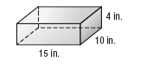

Name of Base: ______________

3-D Figure: _______________

Surface Area or Volume

lateral or total Formula: _________________

P = _________ Substitute: ________________

B = ________ Solution (with labels):

= ________ _____________________

6 in.



20 in.

47. What is the minimum amount of cardboard box needed to **completely cover** the tissue box?



Name of Base: ______________

3-D Figure: _______________

Surface Area or Volume

lateral or total Formula: _________________

P = _________ Substitute: ________________

B = ________ Solution (with labels):

= ________ _____________________



9.5 cm



22.5 cm

48. What is the approximate volume of the sphere? Round the answer to the nearest tenths.



r = ________

Formula: _________________

Substitute: ________________

Solution (with labels):

r = ________________________



49. What is the approximate volume of the sphere? Round the answer to the nearest hundredths.



r = ________

Formula: _________________

Substitute: ________________

Solution (with labels):

r = ________________________



50. Shop class is making a wood box with a base of 7ft by 3ft and a height of 10ft. If the class wishes to paint **the sides only** of the box, what would be the surface area that is being painted?

Name of Base: ______________

3-D Figure: _______________

Surface Area or Volume

lateral or total Formula: _________________

P = _________ Substitute: ________________

B = ________ Solution (with labels):

= ________ _____________________









51. Tanner has 250 cubic centimeters of water that he needs to put into a container. He has the option of using either of the figures shown below.

|  |  |
| --- | --- |
| **Container I** | **Container II** |
| [Description: http://t1.gstatic.com/images?q=tbn:ANd9GcRMsaYW-PJCm9VQn4bpXLJMh5XoHyUKDnT1aOXCr2df_F6K4FNb-Q](http://www.google.com/url?sa=i&rct=j&q=sphere&source=images&cd=&cad=rja&uact=8&docid=TJLhUkRJVTS9vM&tbnid=Xe21WvdRYcl_LM:&ved=0CAUQjRw&url=http://www.pitt.edu/~ajr132/HW13.html&ei=_S1xU_eNJ8bt8QHYnYGgDg&bvm=bv.66330100,d.aWw&psig=AFQjCNFm-AygOpM1C2_zwRBXXE72GnZiaw&ust=1400012650012750)  *r* = 4 cm | 5 cm |

Which container could Tanner use or could he use both? ____________________________

**Container II**

Name of Base: __________ 3-D Figure: ____________

r = ________ Formula: _________________

B = ________ Substitute: ________________

= _________ Solution (with labels):

_________________

**Container I**

r = ________

Formula: _________________

Substitute: ________________

Solution (with labels):

r = ________________________

52. A company is making a gift with a base of 12 in by 6 in and a height of 20 in. What would be the surface area of the **entire** gift box?

20 in

6 in

Name of Base: ______________

3-D Figure: _______________

Surface Area or Volume

lateral or total Formula: _________________

P = _________ Substitute: ________________

B = ________ Solution (with labels):

= ________ _____________________

12 in

53. Madison has 750 cubic centimeters of water that she needs to put into a container. She has the option of using either of the containers shown below.

|  |  |
| --- | --- |
| **Container I** | **Container II** |
|  | [Description: http://t1.gstatic.com/images?q=tbn:ANd9GcRMsaYW-PJCm9VQn4bpXLJMh5XoHyUKDnT1aOXCr2df_F6K4FNb-Q](http://www.google.com/url?sa=i&rct=j&q=sphere&source=images&cd=&cad=rja&uact=8&docid=TJLhUkRJVTS9vM&tbnid=Xe21WvdRYcl_LM:&ved=0CAUQjRw&url=http://www.pitt.edu/~ajr132/HW13.html&ei=_S1xU_eNJ8bt8QHYnYGgDg&bvm=bv.66330100,d.aWw&psig=AFQjCNFm-AygOpM1C2_zwRBXXE72GnZiaw&ust=1400012650012750)*r* = 6 cm |

Which container could Madison use or would the water fit in either container? _________________

**Container II**

r = ________

Formula: _________________

Substitute: ________________

Solution (with labels):

r = ________________________

**Container I**

Name of Base: __________ 3-D Figure: ____________

r = ________ Formula: _________________

B = ________ Substitute: ________________

= _________ Solution (with labels):

_________________

54. A manufacturer is making a new soda can for their product line. About how many cubic centimeters of soda will be needed to **fill** the soda can?

Name of Base: ______________ 3-D Figure: _______________

Surface Area or Volume

lateral or total Formula: _________________

B = ________ Substitute: ________________

= _________ Solution (with labels):

h = ________ _____________________

r = 3.2 cm

13 cm

55. A manufacturer is making a new soup can for their product line and needs a new label. If the label was to **cover only the round portion of the can**, about how many inches of label would they need for each can?

r = 1.4 in

Name of Base: ______________ 3-D Figure: _______________

Surface Area or Volume

lateral or total Formula: _________________

P = ________ Substitute: ________________

r = _________ Solution (with labels):

h = ________ _____________________

6 in

56. Solve each equation and check your solution:

4x + 2(x + 2) = 5(x – 1) 0.4x – 4 = 8 – 0.6x 3(2x + 2) – 4(x – 5) = 18

57. Laura solved an inequality and graphed her solution on the number line below.



What solution is graphed on this number line? **_______________**

58. What solution does each graph represent? 59. Graph each solution.













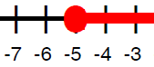



60.Solve and graph each inequality:

$-2x+7< -13$ $3x+5 ≥26$

 