Expressions and the Number System

|  |  |
| --- | --- |
| 1. A square rug has an area of 225 square feet. How long is each side of the rug?  A 15 feet  B 22.5 feet  C 23 feet  D 25 feet | 2. Which is an estimate of  to the nearest hundredth?  A 1.4 C 3.47  B 3.7 D 3.74 |
| 3. Which rational number is also an integer?  A  C  B  D | 4. Which statement is false?  A All whole numbers are integers.  B All irrational numbers are real.  C Some integers are irrational.  D Some integers are whole numbers. |
| 5. Which of the following are true?  I.  II.  III.  A only I and II  B only II and III  C none of them  D all of them | 6. One type of ant is 0.0035 meter long.  How is this length expressed in scientific notation? |
| 7. The population of a large U.S. city is 2,707,210. How is this population expressed in scientific notation? | 8. What is the standard notation for a distance of 9.302 × 107 miles? |

|  |  |
| --- | --- |
| 9. Classify  as a whole number, integer, rational number, irrational number, or real number. Write all the names that apply. | 10. Matthew builds toy cars for a hobby. He wants to organize his tires by circumference size from least to greatest. The tire sizes, in cm, are listed below. List them in order from least to greatest. |
| 11. Between which two consecutive integers does lie?  **A** 5 and 6  **B** 6 and 7  **C** 22 and 23  **D** 44 and 46 | 12. The number line represents the weights of various rocks from Geology class (in grams).  [image]  Which order below represents the weights from least to greatest?  **A**  **B**  **C**  **D** |

13. Place the following real numbers in the Venn diagram where they belong.



|  |  |  |  |  |  |  |  |
| --- | --- | --- | --- | --- | --- | --- | --- |
|  |  | Rational | | |  |  | Irrational |
|  | Integer | | |  |
|  |  | Whole |  |  |
|  |  | Natural |  |  |

Pythagorean Theorem

1. Which of the following models the Pythagorean Theorem?

|  |  |  |
| --- | --- | --- |
| A | B | C |

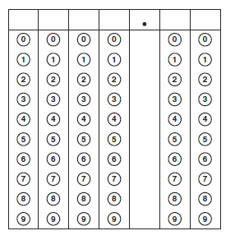2. The right triangle shown below is formed by joining three squares at their vertices. What is the **area** of the smallest square?

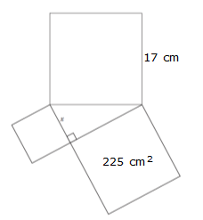

3. A triangle has the following measurements: 13 cm, 12 cm, and 5 cm. Is this a right triangle?

|  |  |
| --- | --- |
| 4. Jake is hanging a bird feeder on a tree in his backyard. He leans an eight-foot ladder against the tree as shown. The distance between the tree and the bottom of the ladder is 6 feet. About how high above the ground is the top of the ladder? | 5. Molly wants to put a fence around an area. The fence will follow the diagram of the triangle shown below.  About how much fencing does Molly need? |
| 6. Susan and her friends are going on a camping trip at Brazos State Park. She needs to bring her tent however the support pole is broken and she will need to by a new one. Based on the dimensions shown in the figure below, approximately how long is the support pole,, for Susan’s tent?  7 ft  8 ft  *t* | 7. A television screen measures approximately 15 inches high and 19 inches wide. A television is advertised by giving the approximate length of the diagonal of its screen. How should this television be advertised?  15 in  19 in |

|  |  |
| --- | --- |
| 8. Dominique is completing a project for her math class using a square piece of poster paper. She will take the poster paper and cut it diagonally from one corner to the other to create triangles. If the poster paper has an area of 256 square inches, what is the approximate length of the diagonal she will cut? | 9. Germany has several flags that consist of two colors separated by a diagonal line as pictured below. If the length of the diagonal is 17 inches and the length of one side is 15 inches, what is the area of the shaded region?  15 in  17 in |
| 10. Find the area of square ABCD.  [image] | 11. Find the length of the hypotenuse.    (-5, -6) |

Transformational Geometry

Use the two triangles for 1–8.

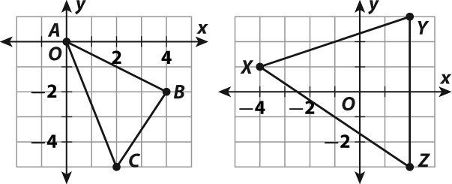

|  |  |
| --- | --- |
| 1. *ABC* is translated 2 units right and  1 unit down. What is the new location  of point *C?*  A (1, -7) C (2, -5)  B (1, -3) D (4, -6) | 2. *ABC* is dilated using a scale factor of 2.5. Which property does **not** change?  A side lengths  B angle measures  C area  D perimeter |
| 3. Which translation moves a triangle 4 units to the right and 8 units up?  A (*x, y*) → (*x* + 4, *y* + 8)  B (*x, y*) → (*x* - 4, *y* + 8)  C (*x, y*) → (*x* + 8, *y* + 4)  D (*x, y*) → (*x* + 8, *y* - 4) | 4. *ABC* is reflected across the *x*-axis. What is the new location of point *B?*  A (-4, -2) C (4, -2)  B (-4, 2) D (4, 2) |
| 5. *ABC* is dilated using a scale factor of 2. What happens to its angle measures?  A They double in size.  B They do not change.  C They become half as great.  D It depends on the center of the dilation. | 6. *ABC* is rotated 90° clockwise about the origin. In what quadrant is *A'B'C'*, the image of the original triangle?  A Quadrant I  B Quadrant II  C Quadrant III  D Quadrant IV |
| 7. *ABC* is rotated 90° counterclockwise with the origin as center of rotation. Where is the image of point *A?*  A (0, 0) C (2, -4)  B (4, -2) D (2, 4) | 8. *XYZ* is dilated using a scale factor of 3. What is the length of *Y'Z'*?  A 2 C 6  B 3 D 18 |

|  |  |
| --- | --- |
| 9. Which property changes when a figure is reflected across a line?  A side lengths  B angle measures  C perimeter  D orientation | 10. Which property changes when a figure is translated?  A side lengths  B angle measures  C location  D perimeter |
| 11. What is the result of the transformation below?  (*x, y*) → (-*x*, *y*)  A reflection across the *x*-axis  B reflection across the *y*-axis  C 90° rotation clockwise  D 90° rotation counterclockwise | 12. andare pictured below.    Are the triangles similar? |
| 13. Marcy glued 24 inches of ribbon around a picture of her family as shown below. If she chooses to enlarge the original picture by multiplying the dimensions by four, how much ribbon will it take to go around the enlarged picture?  8 units | 14. Rectangle *ABCD* and rectangle *LMNO* are similar. If the area of rectangle *ABCD* is 80 units2, what is the **area** of rectangle *LMNO*?    *A* BML 2 units  *C*  *N*  *O*  *D* |

Linear Functions

|  |  |
| --- | --- |
| 1. Which line has a slope of -2?  8_MTXEAR065611_013T | 2. Which line has a slope of  and a negative *y*-intercept?  8_MTXEAR065611_054T |
| 3. Graph the equation.  8_MTXEAR065611_018T | 4. The fuel mileage of a hybrid vehicle is shown in the table below.   |  |  |  |  |  | | --- | --- | --- | --- | --- | | Fuel (gal) | 6 | 9 | 27 | 40 | | Distance (mi) | 192 | 288 | 864 | 1280 |  1. Is the relationship a direct variation?   If so, write an equation that describes the relationship.  \_\_\_\_\_\_\_\_\_\_\_\_\_\_\_\_\_\_\_\_\_  b. How many miles can the car drive on 11 gallons of fuel? \_\_\_\_\_\_\_\_ |
| 5. What is the slope and *y*-intercept of the graph of *y* = 3*x* + 5?  slope = \_\_\_\_\_    *y*-intercept = \_\_\_\_\_\_\_\_\_\_\_\_\_\_\_\_\_ | 6. Which statement **cannot** be true of the graph of a proportional relationship?  A It is not linear.  B It is a straight line.  C It includes the origin.  D It shows a constant ratio. |
| 7. Which equation shows a proportional relationship?  A  C  B  D | 8. Does the data show direct variation? Write *yes* or *no*. If the data shows direct variation, identify the constant of variation and write an equation to describe the relationship.   |  |  |  |  |  | | --- | --- | --- | --- | --- | | Thickness (in.) | 1 | 2 | 3 | 4 | | R-value | 3.14 | 6.28 | 9.42 | 12.56 |   Direct variation: yes no (circle one)  If yes, constant of variation: k = \_\_\_\_\_\_  Equation: \_\_\_\_\_\_\_\_\_\_\_\_\_\_ |

9. On a two-week job, a repairman works a total of 70 hours. He charges $75 plus $40 per hour. An equation shows this relationship, where *x* is the number of hours and *y* is the total fee.

Write the equation for this situation: \_\_\_\_\_\_\_\_\_\_\_\_\_\_\_\_

Identify the slope (rate of change): \_\_\_\_\_\_\_\_\_

What is the y-intercept? \_\_\_\_\_\_\_\_\_\_

10. Solve this system by graphing.

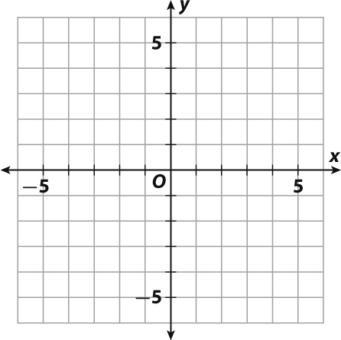 

Solution: \_\_\_\_\_\_\_\_

11-20. Identify whether or not each represents a function **and explain why or why not**.

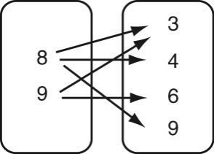 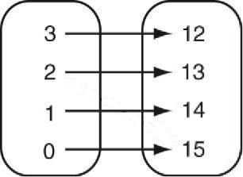 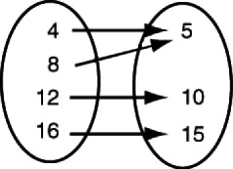

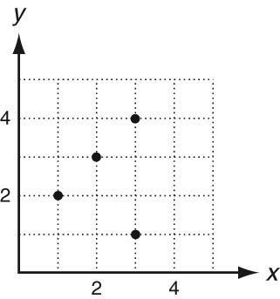 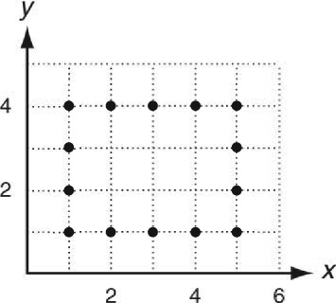 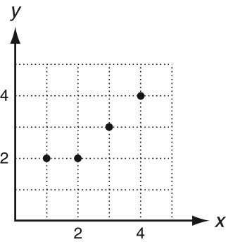

|  |  |  |  |  |
| --- | --- | --- | --- | --- |
| **Input** | 0 | 1 | 2 | 3 |
| **Output** | 4 | 1 | 0 | 4 |

|  |  |  |  |  |  |
| --- | --- | --- | --- | --- | --- |
| **Input** | 1 | 2 | 0 | 1 | 2 |
| **Output** | 4 | 5 | 6 | 7 | 8 |

{(0, 0), (2, 4), (3, 6), (5, 5), (7, 6)} {(0, 8), (1, 2), (3, 7), (5, 9), (3, 6)}