Name: ________________________________________ Date: _____________ Period: _____

Solving Inequalities Using Multiplication and Division Notes

Solve and graph the following inequalities.

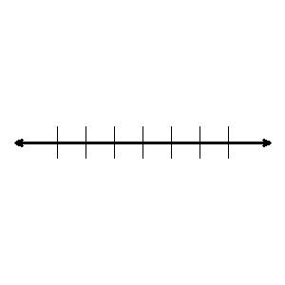1.  2. 



3.  4. 

**Rule**: When you multiply or divide an inequality by a negative number, you must change the

_______________________________________________________.

5. 6. 



7.  8.



Solve each problem with an inequality.

**Phrase: Inequality:**

No more than __________

At least __________

No less than __________

At most __________

A minimum of __________

More than ___________

Less than ___________

9. Suppose you earn $ 7.50 for every lawn you mow. You need to earn at least $120 to pay for camp. How many lawns must you mow?

10. A gallon jug of milk cost $1.20. What is the greatest number of jugs of milk that you can buy with $10?

11. 12. 



13. 14.



15. 16. 



17.  18.



**Underline or highlight the inequality phrase. Write the verbal sentence as an inequality. Solve the inequality and graph your solution on a number line.**

19. The product of 8 and *x* is greater than 50.

Inequality: __________________ Solution: _____________



20. The quotient of *v* and -9 is less than -18.

Inequality: __________________ Solution: _____________

