Solve each of the following systems using graphing. Show all work and write your solution as an ordered pair. Check your solution.

1.) *y* = 4*x* – 9 2.) 

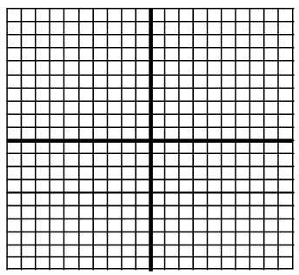 *y* = *x* + 3 



Solution ______ Solution ______

Check : Check :

3.) *y* = -*x* + 9 4.) *y* = 2*x* – 4

*y* = -*x* – 3 *y* = -*x* – 7



Solution ______ Solution ______

Check : Check :

5.)  6.) *y* = -2*x* + 7

y = -4x + 5 *y* = 3



Solution ______ Solution ______

Check : Check :

7.) y = -2x + 9 8.) *y* = -*x* – 8

  *y* = *x*

Solution ______ Solution ______

Check : Check :